NumPy Fundamentals
From Python Lists to Neural Networks
A study companion to the notebook
No prior NumPy, machine learning or calculus knowledge assumed

Contents
Contents 2
1. How to use this guide 6
1.1 What this guide is, and how it differs from the others 6
1.2 A note on level 6
1.3 Features that help you read it 6
1.4 What you already need to know 7
1.5 Suggested reading order 7
1.6 A decoder for the jargon 7
Array 7
Vectorisation 7
Shape 7
Element-wise 8
Scalar, vector, matrix, tensor 8
Model, weights, training 8
2. What the notebook is 9
2.1 The two questions it answers 9
2.2 The shape of the lesson 9
2.3 What makes it unusual 9
2.4 The files 9
2.5 The twelve steps at a glance 10
3. Tools and setup 11
3.1 What you need 11
3.2 Installing and running 11
3.3 Why a virtual environment 11
3.4 Why the last command uses a full path 12
3.5 If something goes wrong 12
4. The problem NumPy solves 13
4.1 What plain lists do instead 13
4.2 The plain Python fix, and why it does not scale 13
5. The NumPy array 15
5.1 The four properties worth knowing 15
5.2 What element-wise actually means 15
6. Why NumPy is fast 17
6.1 Reason one: how the numbers are stored 17
6.2 Reason two: where the loop runs 18
6.3 The measurement 18
6.4 When vectorisation does not help 18
7. Creating arrays 20
7.1 The constructors 20
7.2 Random numbers, and why the seed matters 20
7.3 Where the notebook uses each of these 21
8. Shapes and dimensions 22
8.1 The four names 22
8.2 reshape 23
The -1 trick 23
8.3 Why flattening matters here 23
9. Indexing and slicing 24
9.1 Basic indexing and slicing 24
9.2 Boolean masking 24
9.3 Fancy indexing 24
10. Broadcasting 26
10.1 You have already used it 26
10.2 The rule 26
10.3 The examples from the notebook 27
10.4 Why nothing is copied 27
10.5 Reading a broadcasting error 27
11. Aggregating along an axis 28
11.1 The trick that makes it stick 28
11.2 Why this matters for the capstone 29
11.3 Where else the capstone uses axis 29
11.4 keepdims, and why softmax needs it 29
12. Dot products and matrix multiplication 31
12.1 The dot product 31
12.2 Matrix multiplication is many dot products 31
12.3 This is a neural network layer 32
12.4 The second benchmark 32
13. The capstone: what is being built 34
13.1 Why softmax regression rather than a full network 34
13.2 The data 35
13.3 Shuffling before splitting 35
13.4 Flattening and normalising 36
13.5 One-hot encoding the labels 36
14. The forward pass and softmax 38
14.1 The two parts 38
14.2 Why the raw scores are not probabilities 38
14.3 What softmax does 38
14.4 The implementation, and the stability trick 38
Why subtract the maximum 39
14.5 The untrained model 39
15. Measuring wrongness: cross-entropy loss 40
15.1 The formula, and what it means 40
15.2 Why the negative log 40
15.3 The implementation 40
The 1e-12 41
15.4 Checking the initial value 41
16. Gradients and gradient descent 42
16.1 What a derivative actually is 42
16.2 Gradient descent 42
16.3 The learning rate 42
16.4 The chain rule, and why this network avoids it 43
16.5 The implementation 44
error 44
grad_W 44
grad_b 44
17. The training loop and evaluation 45
17.1 The loop 45
17.2 What the four lines correspond to 45
17.3 The loss curve 46
17.4 Evaluation 46
17.5 What the notebook says about the result 46
18. Checking the maths: gradient checking 48
18.1 The idea 48
18.2 The implementation 49
18.3 Why epsilon is 1e-4 49
18.4 What the check proves 49
19. How this connects to real frameworks 51
19.1 What the frameworks add 51
19.2 What you gain from having done it by hand 51
20. Errors you will actually meet 53
20.1 Shape errors 53
20.2 Errors that do not error 53
20.3 A debugging checklist 54
21. Practice exercises 55
21.1 Core NumPy 55
21.2 The capstone 56
22. Test yourself 57
23. Glossary 59
24. NumPy quick reference 61
24.1 Creating arrays 61
24.2 Describing and reshaping 61
24.3 Selecting 61
24.4 Maths 62
24.5 Aggregating 62
24.6 The capstone in twelve lines 62
25. Where this information came from 63
25.1 What has been added 63

This contents list is a Word field. Open the document, click the list and press F9 to fill in the page numbers.

1. How to use this guide

1.1 What this guide is, and how it differs from the others
This guide accompanies a Jupyter notebook that teaches NumPy, Python's library for working with arrays of numbers. It builds from plain Python lists all the way up to a working neural network written from scratch, using nothing but NumPy.
If you have read the companion guides to the TensorFlow and PyTorch projects, expect something different here. Those documents analysed a piece of software: what it was built from, how it worked, what it was for. This one accompanies a lesson. The notebook is not solving a problem, it is teaching a skill, and the skill is what matters.
So this guide is organised differently:
Those guides | This guide
Explained one finished thing | Explains a sequence of techniques, each building on the last
Sections mapped to the project's parts | Sections map to concepts you need to hold in your head
Told you why the code was written that way | Tells you when and why you would reach for each technique yourself
Ended with limitations and use cases | Ends with error messages, practice exercises and a working reference
The practical difference is that you should read this one with the notebook open. Reading about broadcasting is much less useful than reading about it, trying it, getting it wrong once, and then reading again.

1.2 A note on level
The notebook itself states that it goes to undergraduate depth, and it does. Steps 1 to 10 are approachable at Level 3, while Steps 11 and 12 reach into derivatives, gradients and the chain rule.
This guide is pitched to match, but with the same scaffolding used in the Level 3 guides: key words before each section, a summary after it, and self-test questions. The harder maths in sections 14 to 18 is always explained in plain English before any formula appears, and no calculus background is assumed. If a formula loses you, read the sentence before it again. The sentence is the point; the formula is shorthand for it.

1.3 Features that help you read it
Key words in this section
A blue box like this lists the key words for a section before you start reading it.
Read it first, then read the section. Do not worry if the words mean nothing yet.
In short
A green box like this sums up the section in one or two sentences.
If you only remember one thing from a section, remember what is in the green box.
Check you understood
A purple box like this gives you questions to test yourself.
The answers are in the section you have just read.
An amber box gives instructions for rebuilding a diagram in another tool. Skip these unless you need to redraw the diagrams yourself.

1.4 What you already need to know
- You can read and write basic Python: variables, lists, loops, functions, and importing a module.
- You have used a Jupyter notebook, or you are happy to be shown.
- You can open a terminal and type a command.
- You do not need any NumPy, machine learning or calculus knowledge. Everything is built from the ground up.

1.5 Suggested reading order
If you want to | Read | Why
Get the notebook running | Section 3 | Environment setup and the kernel.
Learn NumPy properly | Sections 4 to 13, in order, with the notebook open | These are the core skills. Each one is used by the next.
Understand the capstone | Sections 14 to 18 | The neural network built from those skills.
Debug something | Section 20 | The error messages you will actually meet, and what they mean.
Practise | Section 21 | Exercises with worked answers.
Look something up | Sections 23 and 24 | Glossary and function reference.

1.6 A decoder for the jargon
A few words appear constantly from here on. Meeting them once now saves stumbling later.

Array
A NumPy array is a grid of numbers, all of the same type, stored together in one block of memory. That description sounds unremarkable and it is the whole reason NumPy exists, as section 6 explains. Everything else in the library is built on it.

Vectorisation
Writing an operation that applies to a whole array at once, instead of writing a Python loop over its elements. It is the single most important idea in the notebook, and it is a style of writing code as much as a feature of the library. Once you start thinking in whole arrays, most of your loops disappear.

Shape
A tuple describing how big an array is along each dimension. (1400, 64) means 1,400 rows and 64 columns. Reading shapes fluently is the most useful practical NumPy skill there is, because shape mismatches cause the majority of errors in real numerical code.

Element-wise
An operation applied to matching pairs of elements. Adding two arrays of the same shape adds the first element to the first, the second to the second, and so on. Contrast with matrix multiplication in section 13, which is a different operation entirely and catches people out.

Scalar, vector, matrix, tensor
Names for arrays with 0, 1, 2 and 3-or-more dimensions. Section 9 covers them. They are just vocabulary, not different kinds of object: in NumPy they are all the same type.

Model, weights, training
From section 14 onwards the notebook builds a small machine learning model. A model is a pile of numbers plus instructions for using them. The numbers are called weights. Training means adjusting them until the answers come out right. There is no reasoning inside it, just arithmetic.

2. What the notebook is
Key words in this section
NumPy: Python's library for arrays of numbers.
Capstone: the final exercise that uses everything taught before it.
MNIST and the digits dataset: collections of labelled handwritten digit images.

2.1 The two questions it answers
The notebook opens by naming its purpose: what is NumPy, and why does it matter enough that the entire Python data science ecosystem is built on top of it?
That second question is the interesting one, and it shapes everything. Pandas, scikit-learn, TensorFlow and PyTorch all lean on NumPy or on its ideas. Understanding NumPy is therefore not one library among many. It is the layer underneath most of the tools you will meet.

2.2 The shape of the lesson
The notebook has 69 cells and a deliberate arc. It does not present NumPy as a list of functions. It builds a case.
1. Steps 1 to 2 show you a problem: plain Python lists cannot do maths element by element.
2. Steps 3 to 4 show the fix, and then measure it, so the speed claim is demonstrated rather than asserted.
3. Steps 5 to 9 build up the working vocabulary: creating arrays, shapes, indexing, broadcasting, aggregation.
4. Step 10 arrives at matrix multiplication and shows that it is exactly what a neural network layer computes.
5. Step 11 uses all of it to build and train a real classifier from scratch.
6. Step 12 verifies the maths from Step 11 numerically, so nothing has to be taken on trust.
Notice the structure of that argument. Every earlier step is used by a later one, and Step 11 uses almost all of them at once. This is a lesson designed so that the capstone is genuinely achievable rather than a leap.

2.3 What makes it unusual
- It measures its own claims. Steps 4 and 10 both include timed benchmarks rather than just saying NumPy is faster.
- It builds a neural network with no machine learning framework at all. No TensorFlow, no PyTorch. Just arrays, matrix multiplication and a loop.
- It checks its own maths. Step 12 verifies the gradient formula numerically, which is a genuinely professional habit and rare in teaching material.
- It explains the calculus in words first. Derivatives, gradients and the chain rule each get a plain English explanation before any notation appears.

2.4 The files
File | What it is
numpy_fundamentals.ipynb | The whole lesson. 69 cells covering Steps 1 to 12, a summary with a glossary, and extension ideas.
README.md | What the notebook covers, what you need, how to install and run it, and four extension exercises.
requirements.txt | Five packages: numpy, matplotlib, scikit-learn, ipykernel and jupyterlab.

2.5 The twelve steps at a glance
Step | Topic | What you can do afterwards
1 | Import NumPy | Use the conventional np alias.
2 | The problem NumPy solves | Explain why plain lists are not enough for numerical work.
3 | The NumPy array | Create arrays and read dtype, shape, size and ndim.
4 | Why NumPy is fast | Explain vectorisation, and why the speed difference is real.
5 | Creating arrays | Use zeros, ones, full, arange, linspace, eye and the random module.
6 | Shapes and dimensions | Read a shape tuple, and reshape an array without changing its data.
7 | Indexing and slicing | Select rows, columns, sub-regions, and use boolean masks and fancy indexing.
8 | Broadcasting | Predict whether two shapes will combine, and why.
9 | Aggregating along an axis | Use sum, mean and argmax with axis=0 and axis=1 correctly.
10 | Dot products and matmul | Apply the shape rule, and recognise a neural network layer when you see one.
11 | The capstone | Build and train a softmax classifier from scratch on real images.
12 | Gradient checking | Verify a gradient formula numerically, without calculus.
In short
The notebook teaches NumPy from first principles and ends by building a working neural network with it.
Every step is used by a later one, so the order matters more than in most tutorials.
It measures its speed claims and checks its own maths rather than asking you to take either on trust.

3. Tools and setup
Key words in this section
Virtual environment (venv): a separate, private copy of Python for one project.
Kernel: the Python process that actually runs the code in your notebook.

3.1 What you need
Package | What it does here | Where it is used
numpy | The subject of the lesson. Arrays and everything done to them. | Every step.
matplotlib | Drawing pictures: the digit images and the loss curve. | Steps 11a, 11e and 11f.
scikit-learn | Supplies the digits dataset. Nothing else. No machine learning from it is used. | Step 11a only, for load_digits().
ipykernel | Registers your environment so Jupyter can run the notebook against it. | Setup only.
jupyterlab | The program you open the notebook in. | Setup only.
The scikit-learn line is worth reading twice. It is a substantial machine learning library, and this notebook uses exactly one function from it: the one that hands over the images. Every piece of maths after that is written by hand with NumPy. The README makes a point of this, and it is what makes the capstone meaningful.
The dataset ships inside scikit-learn itself, so there is no download. The notebook works fully offline.

3.2 Installing and running
# 1. Create a private Python environment for this project
python -m venv .venv

# 2. Turn it on
.venv\Scripts\activate # Windows
source .venv/bin/activate # macOS or Linux

# 3. Install the five packages
pip install -r requirements.txt

# 4. Tell Jupyter about this environment
python -m ipykernel install --user --name=numpy-fundamentals-venv \
--display-name "Python (numpy-fundamentals-venv)"

# 5. Start Jupyter using the full path to this environment
.venv\Scripts\jupyter-lab.exe # Windows
.venv/bin/jupyter-lab # macOS or Linux
When Jupyter opens, check the kernel is set to Python (numpy-fundamentals-venv). In VS Code the kernel picker is at the top right. In Jupyter Lab it is under Kernel then Change Kernel.

3.3 Why a virtual environment
Different projects often need different versions of the same library. Install everything into one shared Python and one project eventually breaks another. The command in step 1 creates a folder called .venv holding a private copy of Python for this project alone.
This is standard professional practice, not something specific to data work. Getting used to it now saves a great deal of trouble later.

3.4 Why the last command uses a full path
Both .venv/bin/jupyter-lab and a plain jupyter lab usually work. The full path removes any doubt about which Python is starting Jupyter, which matters because Jupyter runs two separate Python processes.
Process | What it does | How it gets chosen
The kernel | Runs the code in your cells. | You pick it in the notebook, from the kernel menu.
The server | Runs the Jupyter interface itself. | Whichever Python was used to start Jupyter.
This notebook has no interactive widgets, so the consequences are milder here than in the digit recognition projects. The habit is still worth keeping.

3.5 If something goes wrong
What you see | Why | What to do
ModuleNotFoundError: No module named 'numpy' | The wrong kernel is selected. | Switch to Python (numpy-fundamentals-venv). If it is missing, re-run step 4.
The Step 4 benchmark shows almost no speedup | Another program is loading the machine, or the timing was noisy. | Re-run the cell. Timings vary between runs, which is worth knowing in itself.
A NameError referring to a variable from an earlier step | Cells were run out of order. | Restart the kernel and run everything from the top. This notebook builds state as it goes.
The capstone loss does not fall | W and b were not reset, or the learning rate was changed. | Re-run the Step 11e cell, which resets the weights at the top for exactly this reason.
The gradient check numbers do not match | The weights changed between computing the analytic and numerical gradients. | Re-run Step 12's cell as a whole rather than in pieces.
In short
Create a virtual environment, install five packages, register the kernel, then start Jupyter using the full path.
scikit-learn is present only to supply the images. All the maths is NumPy.

4. The problem NumPy solves
Key words in this section
Element-wise: applying an operation to matching pairs of elements.
List comprehension and zip: the plain Python way of pairing up two lists.
The notebook opens by showing you the problem before showing the solution, which is the right order. You cannot appreciate a fix you have not felt the need for.

4.1 What plain lists do instead
Suppose you have two lists of numbers and you want to subtract one from the other, element by element.
prices = [100, 250, 75, 400]
discounts = [10, 25, 5, 40]

prices - discounts # TypeError
Python raises an error. It has no idea what subtracting one list from another should mean, and rather than guess it refuses.
Multiplication is worse, because it does not error. It does something, and the something is not what you wanted.
prices * 2
# [100, 250, 75, 400, 100, 250, 75, 400]
# Repetition, not scaling
This is the more dangerous case. An operation that fails loudly is easy to fix. An operation that succeeds and gives you the wrong kind of answer can travel a long way through a program before anyone notices.

4.2 The plain Python fix, and why it does not scale
final_prices = []
for price, discount in zip(prices, discounts):
final_prices.append(price - discount)
This works. For four numbers it is perfectly reasonable. The notebook then asks you to imagine doing it for an image with thousands of pixels, or a batch of thousands of images, and the reasonableness evaporates.
There are two separate problems with the loop, and it is worth separating them because they are often conflated.
Problem | What it costs you
It is slow | Every iteration goes through the Python interpreter, which adds overhead to each individual step. Section 6 measures this.
It is verbose | Three lines instead of one, and the intent (subtract these) is buried in the mechanics (make a list, loop, append).
The second problem matters more than people expect. Vectorised code is not just faster, it is shorter and reads closer to the mathematics it implements. In Step 11 you will see a whole training loop with no per-image loop anywhere in it, and that is what makes it readable.
In short
Plain Python lists cannot do maths element by element. Subtraction errors, and multiplication repeats rather than scales.
You can write a loop, but it is slow and it buries your intent in mechanics.

5. The NumPy array
Key words in this section
ndarray: NumPy's array type, the thing everything else operates on.
dtype: the single data type shared by every element.
shape, size, ndim: three properties describing an array's dimensions.
import numpy as np

prices_arr = np.array([100, 250, 75, 400])
discounts_arr = np.array([10, 25, 5, 40])

prices_arr - discounts_arr # array([ 90, 225, 70, 360])
prices_arr * 2 # array([200, 500, 150, 800])
Both problems from section 4 disappear at once. Subtraction works element by element. Multiplication scales rather than repeats. No loop, and the code now reads as the maths it performs.
The alias np is a convention, not a requirement. It is close to universal, though, so use it. Code written with any other alias looks wrong to every Python programmer who reads it.

5.1 The four properties worth knowing
Property | What it tells you | Example on a (1400, 64) array
dtype | The data type shared by every element. All elements have the same type, unlike a list. | float64
shape | The size along each dimension, as a tuple. | (1400, 64)
size | The total number of elements. | 89,600
ndim | How many dimensions the array has. | 2
dtype is doing more work than it appears to. Because every element shares one type, NumPy does not have to check the type of each element as it goes. That is one of the reasons arrays are fast, and section 6 develops the point.
shape is the property you will use constantly. Printing it while debugging is the fastest way to find out why an operation refused. Make it a reflex: when something fails, print the shapes.

5.2 What element-wise actually means
Every arithmetic operation on arrays of the same shape works pair by pair: first with first, second with second, and so on. The result has the same shape as the inputs.
Expression | Result | Note
a + b | Element-wise addition | Shapes must match, or be broadcastable (section 11)
a - b | Element-wise subtraction
a * b | Element-wise multiplication | NOT matrix multiplication. This catches people out constantly.
a / b | Element-wise division | Used in the capstone to normalise pixels: x / 16.0
a ** 2 | Every element squared
a > 20 | An array of True and False | The basis of boolean masking, section 10
a @ b | Matrix multiplication | A different operation entirely. Section 13.
That distinction between * and @ is the single most common source of quiet, wrong answers in NumPy code. Both are valid operations, both often run without error, and they compute completely different things. Section 13 covers @ properly.
In short
np.array turns a list into an ndarray, and arithmetic on it works element by element.
dtype, shape, size and ndim describe an array. shape is the one you will print most.
* is element-wise multiplication. @ is matrix multiplication. They are not the same thing.
Check you understood
1. What does prices_arr * 2 do, and how does that differ from prices * 2 on a plain list?
2. Why does every element of an array having the same type help performance?
3. What is the difference between a * b and a @ b?

6. Why NumPy is fast
Key words in this section
Vectorisation: expressing an operation on a whole array at once rather than looping.
Contiguous memory: values stored next to each other in one block.
Interpreter overhead: the cost Python adds to every step of a Python-level loop.
The notebook calls this the heart of why we use NumPy, and it gives two reasons rather than one. They are related but genuinely separate, and understanding both is what lets you predict when NumPy will help and when it will not.

6.1 Reason one: how the numbers are stored
A Python list is not really a list of numbers. It is a list of pointers to separate Python objects, scattered around memory, each carrying its own type information. Reading through a list means following those pointers one at a time to wherever each object happens to live.
A NumPy array stores its numbers directly, next to each other, in one block, all of the same type. This suits how computer memory and processors actually work: hardware is designed to stream through consecutive memory quickly, and it can do that here.
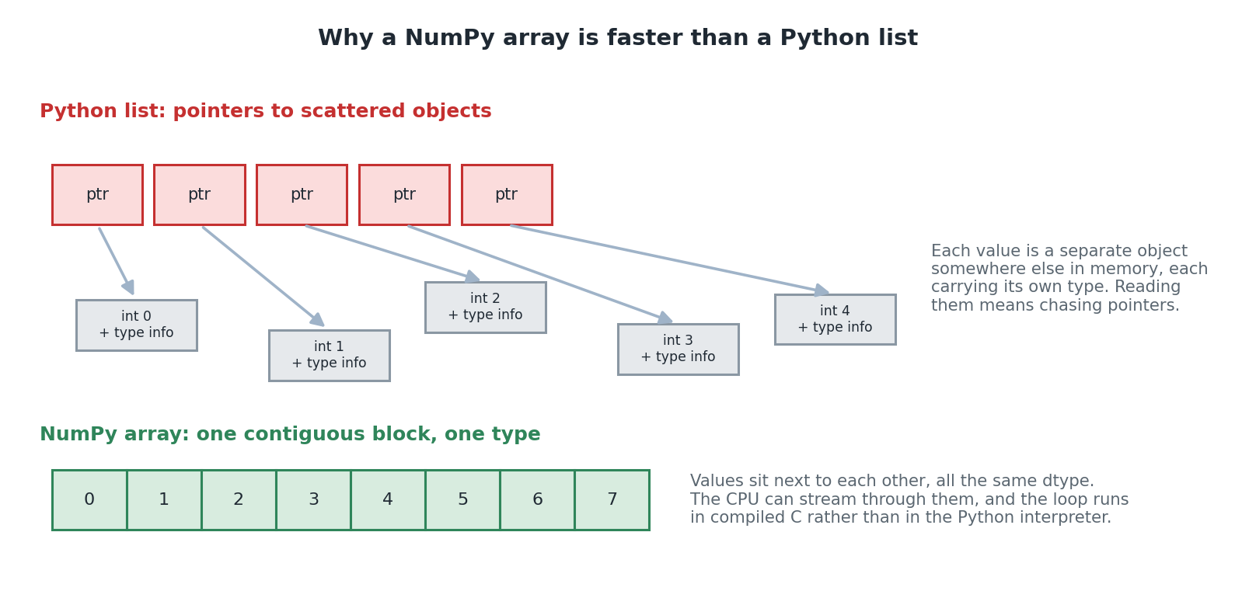
Diagram 1. A Python list holds pointers to scattered objects. A NumPy array holds the values themselves, in one block.

6.2 Reason two: where the loop runs
When you write prices_arr - discounts_arr, NumPy does not run a Python loop at all. It hands the whole operation to pre-compiled, optimised C code, which loops internally.
That distinction is the important one. The loop still happens, it just happens somewhere much cheaper. A Python-level loop pays interpreter overhead on every single iteration: checking types, managing memory, dispatching the operation. Multiply that by five million iterations and it dominates the actual arithmetic.
This is what vectorisation means: expressing an operation on a whole array at once, so that the looping happens in compiled code rather than in your Python.

6.3 The measurement
The notebook does not ask you to take the claim on trust. It times both approaches on five million numbers.
n = 5_000_000
python_list = list(range(n))
numpy_array = np.arange(n)

# A: pure Python loop
total = 0
for value in python_list:
total += value

# B: NumPy's vectorised sum
total_np = numpy_array.sum()
Both compute exactly the same answer. On a typical machine NumPy comes out tens to over a hundred times faster.
Then the notebook makes the point that actually matters: multiply that gap by every operation in a training loop, running thousands of times, and the difference between usable and unusably slow becomes very real. It is not about one sum. It is about the same gap appearing everywhere, repeatedly.
Your exact figure will vary between runs and machines. That variability is worth noticing rather than ignoring: a single timing is a weak measurement, and if you were benchmarking seriously you would repeat it. For demonstrating a hundredfold difference, one run is plenty.

6.4 When vectorisation does not help
This is not in the notebook, and it is worth knowing so you do not over-apply the idea.
- On very small arrays, NumPy's per-call overhead can make it slower than a plain loop. The advantage appears with size.
- When each step genuinely depends on the previous one, there may be nothing to vectorise. Some algorithms are inherently sequential.
- When the operation is not numeric. NumPy is for numbers, and arrays of Python objects lose most of the benefit.
- When the array does not fit in memory. Contiguous storage is a strength until the block is too big to allocate.
In short
Two things make arrays fast: values stored contiguously with one shared type, and operations running as compiled code instead of Python loops.
Vectorisation means writing whole-array operations so the looping happens in C, not in your program.
The notebook measures a speedup of tens to over a hundred times, and that gap repeats across every operation in a training loop.
Check you understood
1. Name the two separate reasons NumPy arrays are faster than Python lists.
2. Does vectorised code avoid looping altogether? Explain.
3. Give one situation where vectorisation would not help.

7. Creating arrays
Key words in this section
Seed: a fixed starting point that makes random numbers reproducible.
Identity matrix: a square array with 1s down the diagonal and 0s elsewhere.
You rarely type out an array by hand. NumPy has constructors for the shapes you actually need, and knowing which to reach for saves a surprising amount of code.

7.1 The constructors
Call | What you get | When you would use it
np.zeros(5) | Five zeros | Initialising storage you are about to fill. The capstone starts its bias at zeros.
np.ones((2, 3)) | A 2 by 3 grid of ones | Initialising, or building a mask you will modify.
np.full(4, 7) | Four copies of the number 7 | Filling with a constant other than 0 or 1.
np.arange(0, 10, 2) | 0, 2, 4, 6, 8 | Like Python's range, but returns an array. Note the stop is excluded.
np.linspace(0, 1, 5) | Five evenly spaced numbers from 0 to 1 | Plotting, or sampling a range. Here the stop IS included.
np.eye(3) | A 3 by 3 identity matrix | Linear algebra, and the one-hot trick in section 14.4.
The arange and linspace difference catches people out. arange excludes its stop value, matching Python's range. linspace includes it, because you are asking for a number of points across a range rather than a step size. When you want exactly n points ending at a known value, linspace is the one you want.

7.2 Random numbers, and why the seed matters
rng = np.random.default_rng(seed=42)

rng.random(4) # floats in [0, 1)
rng.integers(0, 10, size=5) # whole numbers 0 to 9
rng.normal(loc=0.0, scale=1.0, size=4) # from a normal distribution
Random numbers appear constantly in machine learning: shuffling data, splitting into training and test sets, and initialising weights. The capstone does all three.
The seed is what makes it reproducible. A fixed seed means everyone who runs the cell gets the same numbers, so results can be compared and bugs can be reproduced. Without one, every run differs slightly and you can never tell whether a change you made helped or whether you just got a luckier shuffle.
This is a professional habit worth adopting early. Reproducibility is not a nicety; it is what makes an experiment an experiment rather than an anecdote.
The notebook uses np.random.default_rng(), which is the modern interface. Older code and tutorials use np.random.seed() with functions like np.random.rand(). Both work, but the newer generator-based style is what current NumPy recommends, and it avoids a shared global state that can surprise you.

7.3 Where the notebook uses each of these
Constructor | Used in the capstone for
np.zeros | The initial bias vector b, ten zeros. A standard, simple starting point.
np.eye | Building one-hot label vectors, via a 10 by 10 identity matrix. Section 14.4.
rng.permutation | Shuffling the images before splitting into training and test sets.
rng.normal | Initialising the weight matrix W with small random numbers, scale 0.01.
Why small random weights rather than zeros? If every weight started identical, every output neuron would compute the same thing and receive the same gradient, so they would never differentiate from one another. Small random values break that symmetry. The bias can safely start at zero because the weights already provide the variation.
In short
zeros, ones, full, arange, linspace and eye cover most of what you need.
arange excludes its stop value; linspace includes it.
Always seed your random generator. Reproducibility is what makes results comparable.

8. Shapes and dimensions
Key words in this section
ndim: how many dimensions an array has.
reshape: rearranging the same numbers into a different shape.
Flatten: collapsing an array into one dimension.
The notebook says that getting comfortable reading shape tuples is one of the most useful NumPy skills there is, because shape mismatches are the single most common source of bugs in real machine learning code. That is not an exaggeration, and section 20 is largely about the errors they produce.

8.1 The four names
ndim | Name | What it looks like | Example here
0 | Scalar | A single number | np.array(7). Shape ()
1 | Vector | A list of numbers | One row of pixel brightnesses. Shape (64,)
2 | Matrix | A grid | One 8 by 8 image. Shape (8, 8)
3+ | Tensor | A stack of grids | All 1,797 images. Shape (1797, 8, 8)
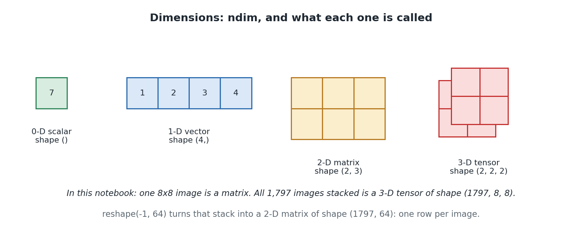
Diagram 2. The same idea at four sizes: scalar, vector, matrix, tensor.
These are names for the same kind of object, not four different types. In NumPy they are all ndarrays. The vocabulary exists because the maths has different names for them, and because saying 'a matrix' is quicker than saying 'a two dimensional array'.

8.2 reshape
tiny_image = np.arange(64).reshape(8, 8) # a 64-number run, laid out as a grid
flattened = tiny_image.reshape(-1) # back to a single row of 64
reshape rearranges the same numbers into a different shape. It does not change any values and it does not, in most cases, copy the data. It changes how the same block of memory is interpreted.
The only rule is that the total number of elements must stay the same. 8 times 8 is 64, so an array of 64 elements can become 8 by 8, or 4 by 16, or 2 by 4 by 8, but never 7 by 9.

The -1 trick
Passing -1 for one dimension means work this one out for me. NumPy calculates it from the total size and the other dimensions you did specify.
x_train = x_train_raw.reshape(-1, n_features) # from (1400, 8, 8) to (1400, 64)
Here you are saying: 64 columns, and however many rows that takes. It is safer than writing 1400 explicitly, because it keeps working if the number of images changes. Get into the habit of using it for the dimension you do not need to name.

8.3 Why flattening matters here
The capstone takes each 8 by 8 image and flattens it to a row of 64 numbers, because the layer it feeds expects a flat list of features rather than a grid.
There is a real cost, and it is worth naming even though this notebook does not dwell on it. Once flattened, the information about which pixels were next to each other is gone. The pixel directly below another is now 8 positions away in a list, and nothing tells the model that means anything. Convolutional networks exist to avoid exactly this loss, and if you have read the TensorFlow or PyTorch guides you have met that argument before.
In short
Shape is a tuple giving the size along each dimension. Reading it fluently prevents most NumPy bugs.
0-D is a scalar, 1-D a vector, 2-D a matrix, 3-D and beyond a tensor. All the same type underneath.
reshape rearranges without changing values. Use -1 for the dimension you want worked out for you.
Check you understood
1. An array has shape (1797, 8, 8). What is its ndim, and what is its size?
2. What does reshape(-1, 64) do to that array, and why is -1 better than writing 1797?
3. What information is lost when an 8 by 8 image is flattened?

9. Indexing and slicing
Key words in this section
Slice: selecting a range with a colon, as in grid[0:2].
Boolean mask: an array of True and False used to select elements.
Fancy indexing: selecting rows or elements using a list of positions.
Selecting part of an array is something you do constantly, and NumPy gives you three quite different ways of doing it. All three appear in the capstone.

9.1 Basic indexing and slicing
grid = np.array([[10, 11, 12, 13],
[20, 21, 22, 23],
[30, 31, 32, 33]])

grid[1, 2] # 22 one element: row 1, column 2
grid[0, :] # row 0 the colon means 'all of this dimension'
grid[:, 1] # column 1
grid[0:2, 0:2] # the top-left 2x2 corner, like cropping an image
grid[-1, :] # the last row
Syntax | Means
grid[1, 2] | One element. Row first, then column.
grid[0, :] | Everything along the second dimension: a whole row.
grid[:, 1] | A whole column. Note this returns a 1-D array, not a column-shaped 2-D one.
grid[0:2, 0:2] | A rectangular sub-region. Start included, stop excluded.
grid[-1, :] | Negative indices count from the end. -1 is the last.
The comma is what makes this different from list indexing. With a plain nested list you would write grid[1][2], indexing twice. NumPy lets you index all dimensions in one go, and that is what makes column selection possible at all: grid[:, 1] has no clean equivalent with nested lists.

9.2 Boolean masking
mask = grid > 20 # an array of True/False, same shape as grid
grid[mask] # only the values where the mask is True
Two things are happening, and separating them helps. First, grid > 20 is an element-wise comparison producing an array of True and False the same shape as the original. Second, indexing with that array pulls out only the elements where it was True.
The notebook points out this is exactly the operation behind thresholding an image into pure black and white, and that it needs no loop: all 12 elements are checked at once by vectorisation.
Note that the result is flattened. Selecting scattered elements from a grid cannot produce a grid, so you get a 1-D array. If you want to keep the shape, use np.where instead, which lets you say what to put in the False positions.

9.3 Fancy indexing
grid[[0, 2]] # rows 0 and 2 only, in that order
Indexing with a list of positions gives you those positions, in the order you asked for. It can repeat, and it can reorder. This is more powerful than it first looks, and the capstone uses it twice for genuinely clever purposes.
Where | What it does
images[shuffled_indices] | Reorders all 1,797 images into a random order in one operation, using a permutation of the positions.
identity[labels] | Turns 1,400 digit labels into 1,400 one-hot rows, by picking the matching row of a 10 by 10 identity matrix for each. Section 14.4.
That second one is worth admiring. Converting labels to one-hot vectors sounds like it needs a loop and some conditional logic. With np.eye and fancy indexing it is a single line and no loop at all. This is what thinking in arrays looks like once it clicks.
In short
grid[row, column] indexes all dimensions at once. A colon means all of that dimension.
A boolean mask selects by condition, and returns a flattened result.
Fancy indexing selects by a list of positions, and can reorder or repeat. It powers both the shuffle and the one-hot encoding in the capstone.

10. Broadcasting
Key words in this section
Broadcasting: NumPy's rule for combining arrays of different but compatible shapes.
Compatible: equal in a dimension, or one of them is 1.
Broadcasting is the idea that most often confuses people and most often makes their code shorter. It is worth learning the rule properly rather than by trial and error, because the rule is short and the trial and error is not.

10.1 You have already used it
prices_arr * 2 from section 5 is broadcasting. The single number 2 is stretched across all four elements. Broadcasting simply generalises that idea to arrays with more than one dimension.

10.2 The rule
Compare the shapes dimension by dimension, starting from the right. Two dimensions are compatible if they are equal, or if one of them is 1, in which case the size-1 dimension is stretched to match. If neither is true for some dimension, NumPy raises an error rather than guessing.
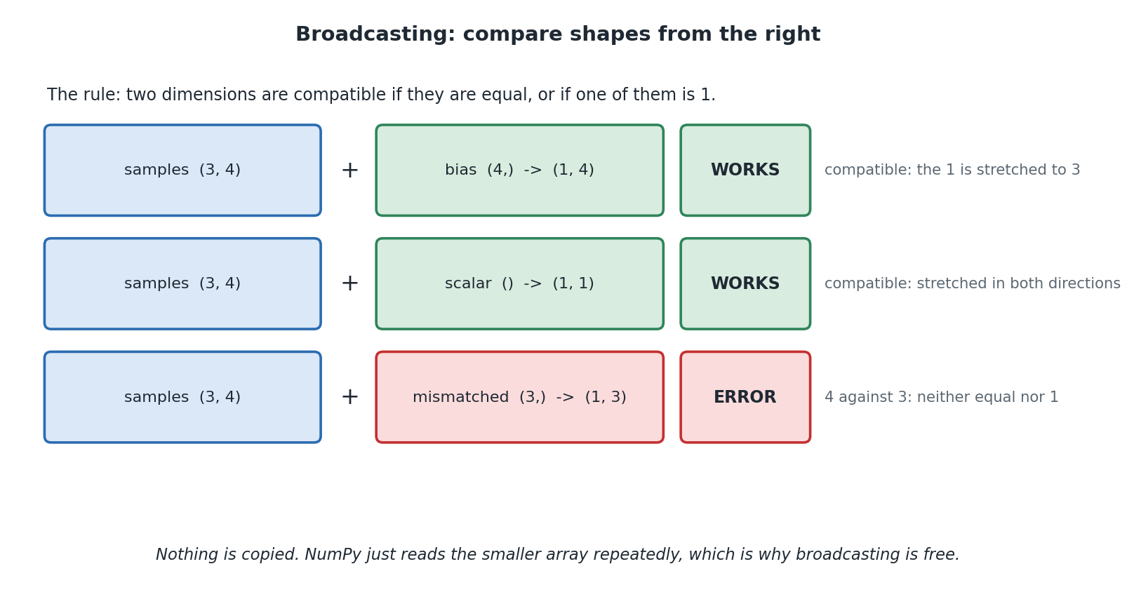
Diagram 3. Three examples of the rule, two that work and one that does not.

10.3 The examples from the notebook
samples = np.array([[1., 2., 3., 4.],
[5., 6., 7., 8.],
[9., 10., 11., 12.]]) # shape (3, 4)

samples + 100 # a scalar broadcasts to every element

bias = np.array([1000, 2000, 3000, 4000]) # shape (4,)
samples + bias # one value per column, applied to every row

mismatched = np.array([1, 2, 3]) # shape (3,)
samples + mismatched # ValueError: 4 does not match 3
The second example is the one that matters most. Adding a 1-D array to every row of a 2-D array is exactly the shape of computation a neural network layer does. Every layer computes output = inputs @ weights + bias for a whole batch at once, and broadcasting is what lets the same bias vector apply to every sample without a loop over samples.
You will see this again in section 13 and again in the capstone, where a bias of shape (10,) is added to a scores array of shape (1400, 10). One line, no loop, 14,000 additions.

10.4 Why nothing is copied
The word stretching suggests NumPy builds a bigger array. It does not. It reads the smaller array repeatedly as it works through the larger one.
This matters practically. If broadcasting did copy, adding a bias to a batch of a million samples would allocate a million copies of the bias, and the technique would be useless at scale. Because it does not, broadcasting is essentially free, and you can use it freely without worrying about memory.

10.5 Reading a broadcasting error
When shapes are not compatible, NumPy tells you rather than silently doing something wrong. The message names both shapes.
ValueError: operands could not be broadcast together
with shapes (3,4) (3,)
Read it as: I lined these up from the right, and 4 against 3 is neither equal nor 1, so I stopped. The fix is either to reshape one of them so the sizes line up, or to realise that you meant a different operation entirely, which is surprisingly often the case.
In short
Compare shapes from the right. Dimensions are compatible if equal, or if one is 1.
Nothing is copied, so broadcasting costs nothing in memory.
Adding a bias vector to every row of a batch is broadcasting, and it is what every neural network layer does.
Check you understood
1. State the broadcasting rule from memory.
2. Will shapes (5, 3) and (3,) broadcast? What about (5, 3) and (5,)?
3. Why does broadcasting not use extra memory?

11. Aggregating along an axis
Key words in this section
Aggregation: collapsing many numbers into fewer, such as summing or averaging.
axis: which dimension gets collapsed.
argmax: the position of the largest value, rather than the value itself.
Functions like sum, mean, max and argmax can collapse an array to a single number, or, given an axis argument, collapse it along just one dimension. The notebook says this trips a lot of people up, and it is right.

11.1 The trick that makes it stick
Picture the array as a spreadsheet with rows and columns.
- axis=0 collapses the rows, combining down each column. You get one result per column.
- axis=1 collapses the columns, combining across each row. You get one result per row.
The notebook offers a rule that is genuinely the best way to remember it: the axis number you pass is the dimension that disappears from the result.
Apply it to a (3, 4) array. Pass axis=0 and dimension 0, the 3, disappears, leaving shape (4,). Pass axis=1 and dimension 1, the 4, disappears, leaving shape (3,). No guesswork, and it generalises to any number of dimensions.
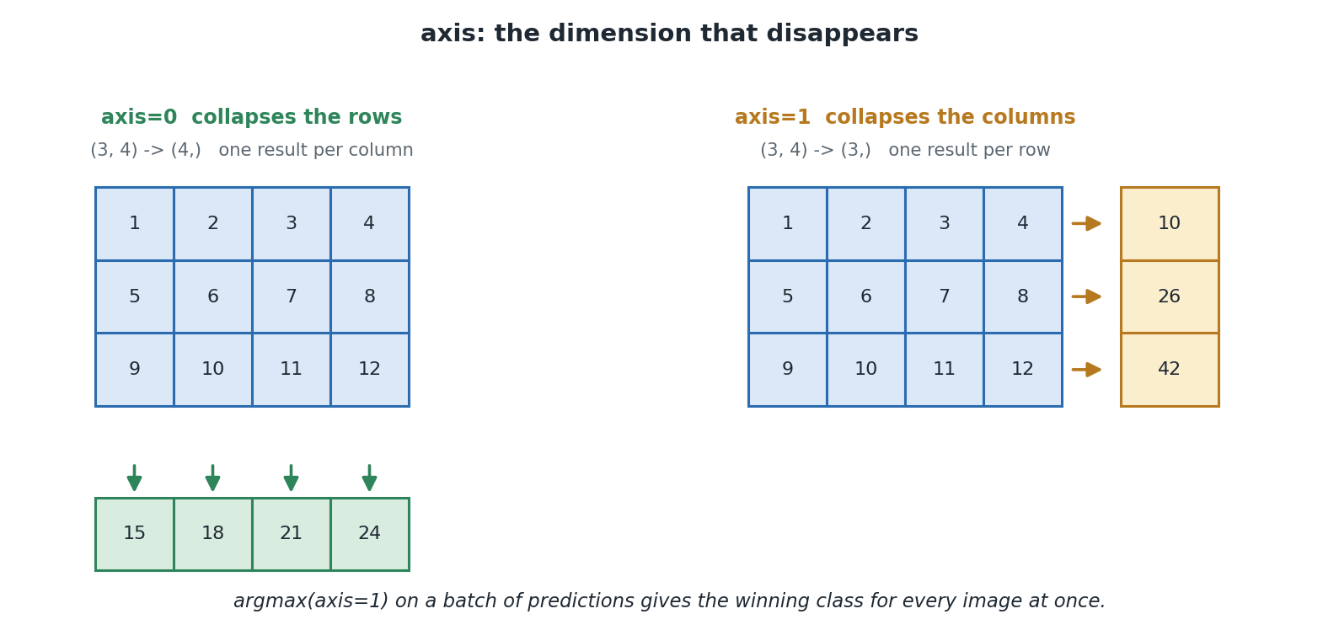
Diagram 4. The same array collapsed two ways. The axis you name is the one that vanishes.

11.2 Why this matters for the capstone
The notebook connects it immediately to something real. A classifier produces one row of probabilities per image, one probability per possible digit. So a batch of 397 test images gives an array of shape (397, 10).
test_predictions = np.argmax(test_probs, axis=1)
argmax with axis=1 picks out, for every image at once, the position of the largest probability in its row. That position is the predicted digit. The result has shape (397,): one prediction per image.
Get the axis wrong here and you would ask which image scored highest for each digit, which is a perfectly valid question and entirely the wrong one. The code would run without error and the answer would be nonsense. This is why the disappearing-dimension rule is worth internalising.

11.3 Where else the capstone uses axis
Code | What it does
scores.max(axis=1, keepdims=True) | The largest score in each row, for softmax's numerical stability trick. Section 15.3.
exp_scores.sum(axis=1, keepdims=True) | The total per row, so each row of probabilities sums to 1.
np.sum(probs * y_onehot, axis=1) | Picks out the probability given to the correct class, for every sample at once.
np.mean(error, axis=0) | The average error per class, across the batch. This is the bias gradient.
np.argmax(test_probs, axis=1) | The predicted digit for every test image.

11.4 keepdims, and why softmax needs it
Two of those calls pass keepdims=True, and it is worth understanding rather than copying.
Normally, collapsing a (1400, 10) array with axis=1 gives shape (1400,), because the collapsed dimension disappears. With keepdims=True it gives (1400, 1) instead: the dimension is kept, at size 1.
Why bother? Because of broadcasting. You want to divide every element of the (1400, 10) array by its own row total. Shape (1400, 1) broadcasts against (1400, 10) correctly, stretching the single column across all ten. Shape (1400,) would be lined up from the right against the 10, and either fail or do something wrong.
This is a good example of two NumPy features interacting. keepdims exists precisely so that aggregation results stay broadcast-compatible with what they came from.
In short
The axis you pass is the dimension that disappears from the result.
axis=0 gives one result per column; axis=1 gives one result per row.
argmax(axis=1) reads off the predicted class for a whole batch at once.
keepdims=True keeps the collapsed dimension at size 1 so the result still broadcasts.
Check you understood
1. An array has shape (100, 10). What shape results from sum(axis=0)? From sum(axis=1)?
2. Why does the capstone use axis=1 rather than axis=0 when reading off predictions?
3. What does keepdims=True do, and why does softmax need it?

12. Dot products and matrix multiplication
Key words in this section
Dot product: multiply matching pairs, then add the results into one number.
Matrix multiplication: many dot products at once.
@: Python's dedicated matrix multiplication operator.
The notebook calls this the mathematical core of every neural network layer, and it is. It is also simpler than its reputation suggests, so take it one piece at a time.

12.1 The dot product
The dot product of two equal-length vectors is: multiply each matching pair of numbers together, then add up all those products into a single number.
a = np.array([1, 2, 3])
b = np.array([4, 5, 6])

# (1*4) + (2*5) + (3*6) = 4 + 10 + 18 = 32
np.dot(a, b) # 32
a @ b # 32, same thing
That is all it is. The notebook is right to say it is no more mysterious than that.
The useful way to think about it is as a weighted sum. If b represents a set of weights, saying how much each number in a should count, then the dot product is the combined, weighted total. Hold onto that reading, because it is exactly what a neuron computes.

12.2 Matrix multiplication is many dot products
To multiply matrix A by matrix B, take the dot product of every row of A with every column of B. Each of those dot products becomes one element of the result.
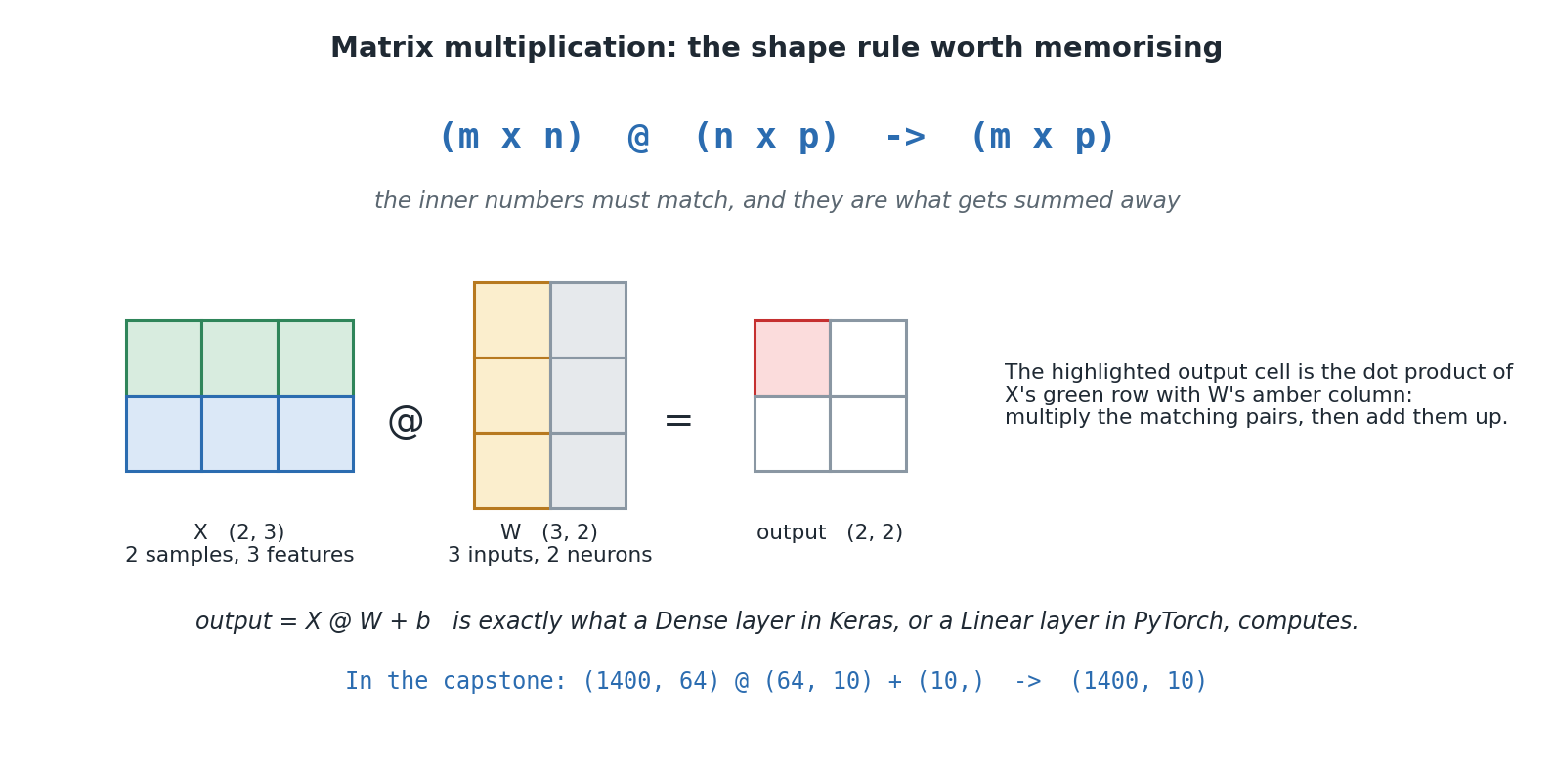
Diagram 5. The shape rule, and where each output element comes from.
The shape rule is the single most important one in machine learning code, and the notebook says it is worth memorising:
(m x n) @ (n x p) -> (m x p)
The middle dimensions must match. That shared number is what gets summed away by each dot product, and it vanishes from the result. If you remember nothing else from this section, remember that line.
X = np.array([[1, 2, 3],
[4, 5, 6]]) # (2, 3): 2 samples, 3 features

W = np.array([[0.1, 0.4],
[0.2, 0.5],
[0.3, 0.6]]) # (3, 2): 3 inputs -> 2 outputs

result = X @ W # (2, 3) @ (3, 2) -> (2, 2)

12.3 This is a neural network layer
The notebook now makes its central claim, and it is worth reading slowly.
A dense or fully-connected layer, exactly like those inside TensorFlow or PyTorch, computes nothing more exotic than:
output = inputs @ weights + bias
Followed by a simple fixed function applied to every number, an activation function such as relu or softmax.
Every neuron is one column of the weight matrix: a set of numbers dot-producted against the inputs to produce one output number. Do that for every column and every sample at once, and matrix multiplication has computed the whole layer for the whole batch, with broadcasting supplying the bias.
If you have read the guides to the TensorFlow or PyTorch projects, this is the moment the three fit together. nn.Linear(784, 128) and Dense(128) both compute this expression. They differ in what they call it and what they do around it. Underneath, it is a matrix multiplication and an addition.

12.4 The second benchmark
The notebook then writes the same computation as a triple-nested Python loop and times both.
batch = rng.random((200, 784)) # 200 samples, 784 pixels each
weights = rng.random((784, 128)) # feeding a layer of 128 neurons
bias = rng.random(128)

# the loop version: for each sample, for each neuron, for each input
# the NumPy version:
vectorised_output = batch @ weights + bias
It checks the answers match with np.allclose, then reports the time difference. The loop performed 200 times 128 times 784, roughly 20 million individual multiplications, for one layer on one small batch.
The notebook draws the conclusion plainly: a real training run repeats this thousands of times, across several layers, in both directions. Without vectorised array maths, training a neural network on a laptop would take an impractically long time. This is why NumPy exists, and why the GPU-accelerated libraries built on the same ideas exist.
np.allclose rather than == is deliberate. Floating point arithmetic in a different order gives answers that differ in the last few decimal places, so exact equality would fail even though both answers are correct. allclose asks whether they agree to within a small tolerance, which is the right question for floating point.
In short
A dot product multiplies matching pairs and sums them: a weighted sum.
Matrix multiplication is many dot products at once. (m x n) @ (n x p) -> (m x p), and the inner numbers must match.
output = inputs @ weights + bias is exactly what a dense layer in any framework computes.
The loop version of one small layer does 20 million multiplications. This is why vectorisation matters.
Check you understood
1. Compute the dot product of [2, 0, 1] and [3, 4, 5] by hand.
2. What shape results from a (1400, 64) array multiplied by a (64, 10) array?
3. Why does the notebook compare results with np.allclose rather than ==?

13. The capstone: what is being built
Key words in this section
Softmax regression: a classifier with no hidden layers, going straight from inputs to class scores.
One-hot encoding: representing a label as a row of zeros with a single 1.
Training and test split: keeping some data back to score the model honestly.
Step 11 uses everything from Steps 1 to 10 to build and train a real classifier on real handwritten digit images, with no machine learning framework at all.
The notebook is honest about what it is building. Real libraries hide an enormous amount behind one line like model.fit(...). This builds a simplified version of what is happening inside that line.

13.1 Why softmax regression rather than a full network
Softmax regression is a neural network with no hidden layers: one layer going straight from the image's pixels to ten digit-class scores. It is simpler than a multi-layer network, and it uses exactly the same core ingredients: a weight matrix, a bias, matrix multiplication, softmax, and gradient descent.
The reason for the choice is mathematical convenience, and the notebook says so. With one layer, softmax combined with cross-entropy loss has a famously clean gradient that can be stated in one line, without grinding through the chain rule. Add a hidden layer and you need backpropagation proper.
This is a well-judged teaching decision. You get a genuinely working classifier, on real data, with maths you can follow completely. The README's first extension suggestion is to add a hidden layer, at which point you would need the chain rule, and by then you would be ready for it.
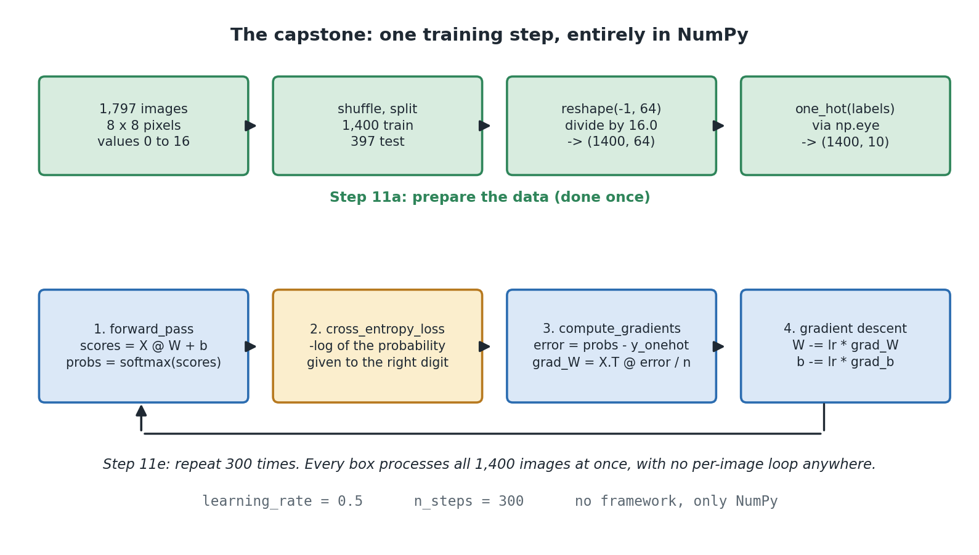
Diagram 6. The capstone in full: data preparation once, then a four-stage loop repeated 300 times.

13.2 The data
from sklearn.datasets import load_digits

digits = load_digits()
images, labels = digits.images, digits.target # (1797, 8, 8) and (1797,)
1,797 real handwritten digit images, each an 8 by 8 grayscale grid, with pixel values from 0 to 16. It is a lower-resolution cousin of the famous 28 by 28 MNIST dataset.
 | This dataset | Full MNIST
Images | 1,797 | 70,000
Size | 8 by 8 | 28 by 28
Pixels per image | 64 | 784
Pixel range | 0 to 16 | 0 to 255
Download needed | No, it ships with scikit-learn | Yes
Time to train here | Under a second | Considerably longer
The README explains the choice: a small, low-resolution dataset means every cell runs almost instantly and the arrays stay small enough to print and inspect. For a lesson that is exactly right. The extension ideas suggest scaling up to full MNIST once you have understood the small version.
Note the pixel range of 0 to 16 rather than 0 to 255. That is why the normalisation later divides by 16.0 rather than 255.0, and it is a good reminder to check your data rather than assume it matches the last dataset you met.

13.3 Shuffling before splitting
rng = np.random.default_rng(seed=1)
shuffled_indices = rng.permutation(len(images))
images, labels = images[shuffled_indices], labels[shuffled_indices]

n_train = 1400
x_train_raw, y_train = images[:n_train], labels[:n_train]
x_test_raw, y_test = images[n_train:], labels[n_train:]
The comment in the notebook explains why this matters: the dataset is stored in repeating blocks of digits 0 to 9. Split it without shuffling and one set could end up missing entire digits, which would be catastrophic and not obviously so.
Two techniques from earlier steps are doing the work here. rng.permutation produces a shuffled list of positions, and fancy indexing from section 9.3 applies that ordering to both arrays at once. Using the same index array for images and labels is what keeps each image with its correct label.
The split is roughly 80 percent training and 20 percent test: 1,400 and 397. The reason for holding data back is the same as in any machine learning project. Testing on data the model has already learned from tells you how well it memorised, not how well it will handle anything new.

13.4 Flattening and normalising
n_features = 8 * 8 # = 64

x_train = x_train_raw.reshape(-1, n_features) / 16.0
x_test = x_test_raw.reshape(-1, n_features) / 16.0
One line does two jobs, both drawn from earlier steps.
- reshape(-1, 64) turns the (1400, 8, 8) stack of images into a (1400, 64) matrix: one row per image, one column per pixel. Section 8.2.
- Dividing by 16.0 scales every pixel from 0-to-16 into 0-to-1. This is vectorisation from section 6 and broadcasting from section 10: one scalar applied to 89,600 numbers, no loop.
Why normalise at all? The same reason as in any neural network. A neuron multiplies inputs by weights and adds them up. With 64 inputs each up to 16, those totals get large before any learning has happened, and large, unevenly scaled inputs make the optimisation unstable and slow. Scaling into a small consistent range makes training behave.

13.5 One-hot encoding the labels
def one_hot(labels, num_classes=10):
identity = np.eye(num_classes) # 10x10, row i is digit i's one-hot vector
return identity[labels] # fancy indexing: one row per label

y_train_onehot = one_hot(y_train) # (1400, 10)
The labels arrive as single digits: 3, 7, 0 and so on. The network will output ten probabilities per image, so the labels need to be in a comparable form. One-hot encoding turns the digit 3 into a row of ten numbers that is all zeros except a single 1 at position 3.
The implementation is worth studying, because it is a small masterpiece of array thinking. np.eye(10) builds an identity matrix whose row i is already exactly the one-hot vector for digit i. Then fancy indexing with the whole labels array picks out the right row for every label at once.
Written as a loop this would be five or six lines with a conditional. Written as arrays it is two lines and no branching. That shift, from thinking about one item at a time to thinking about the whole collection at once, is the real skill this notebook teaches.
In short
The capstone builds softmax regression: one layer, straight from 64 pixels to 10 class scores.
Data prep: shuffle, split 1400/397, flatten to (1400, 64), divide by 16.0, one-hot the labels.
Every one of those steps uses a technique from Steps 5 to 10.

14. The forward pass and softmax
Key words in this section
Forward pass: running data through the model to get a prediction.
Logits or scores: the raw numbers before they are turned into probabilities.
Softmax: turns a row of raw scores into probabilities summing to 1.

14.1 The two parts
The forward pass has two stages. First a matrix multiplication produces ten raw scores per image. Then softmax turns those scores into probabilities.
def forward_pass(X, W, b):
scores = X @ W + b # (n, 64) @ (64, 10) + (10,) -> (n, 10)
return softmax(scores)
Look at the shapes in that comment, because they tie the whole notebook together. (1400, 64) @ (64, 10) gives (1400, 10) by the rule from section 12.2. Then a bias of shape (10,) is added to all 1,400 rows by broadcasting from section 10. Two lines of maths, two ideas taught earlier, and 1,400 images predicted at once.

14.2 Why the raw scores are not probabilities
The scores coming out of X @ W + b can be any real number, including negatives. They are not probabilities: they do not sit between 0 and 1 and they do not add up to anything in particular. They are just how strongly the model currently favours each digit.

14.3 What softmax does
For each score in a row, softmax computes the exponential of that score, divided by the total of the exponentials of every score in the row.
In plain English: exponentiate every score, which makes everything positive and makes bigger scores count disproportionately more since exp grows very fast, then divide each by the total so they end up between 0 and 1 and add up to exactly 1.
# illustrative
scores [2.0, 1.0, 0.1 ]
after exp [7.39, 2.72, 1.11]
total 11.22
after dividing [0.659, 0.242, 0.099] adds to 1.0
The digit with the highest raw score still ends up with the highest probability. Softmax does not change the ranking, it reshapes the scores into something that behaves like a probability distribution.
Because they sum to 1, you can read them as confidence, and it builds in the rule that only one answer can be right: raising one digit's probability necessarily lowers the others.

14.4 The implementation, and the stability trick
def softmax(scores):
shifted = scores - scores.max(axis=1, keepdims=True)
exp_scores = np.exp(shifted)
return exp_scores / exp_scores.sum(axis=1, keepdims=True)
Three lines, and every one of them uses something from earlier. Both aggregations use axis=1 to work per row, and both use keepdims=True so the results stay broadcast-compatible, exactly as section 11.4 described.

Why subtract the maximum
The first line looks like it should change the answer and does not. Subtracting the same number from every score in a row leaves softmax's output unchanged, because the subtraction turns into a common factor that cancels in the division.
It is there purely to avoid overflow. exp grows extremely fast: exp(1000) is far beyond what a floating point number can hold, and you would get inf, then inf divided by inf, then nan, and every subsequent calculation would be poisoned. Subtracting the row maximum guarantees the largest value passed to exp is 0, so exp never exceeds 1.
This is a nice piece of practical numerical programming, and worth noticing. A formula that is correct on paper can still fail in floating point, and the fix is often an algebraic rearrangement that changes nothing mathematically and everything computationally.

14.5 The untrained model
rng = np.random.default_rng(seed=2)
W = rng.normal(loc=0.0, scale=0.01, size=(n_features, 10))
b = np.zeros(10)

probs = forward_pass(x_train[:1], W, b)
With small random weights the output should look close to a uniform guess: roughly 0.1 for every digit. The notebook says so explicitly, and checking it is worthwhile.
Think about why. The weights are tiny, so the scores are all close to zero, so exponentiating gives numbers all close to 1, so dividing by the total gives ten roughly equal probabilities. An untrained ten-class model that is confident about anything would be a sign something is wrong.
In short
forward_pass is X @ W + b followed by softmax. Matrix multiplication plus broadcasting, then normalisation.
Softmax exponentiates and divides by the row total, giving probabilities that sum to 1 without changing the ranking.
Subtracting the row maximum first prevents overflow and changes nothing mathematically.
An untrained model should output about 0.1 for every digit.

15. Measuring wrongness: cross-entropy loss
Key words in this section
Loss: a single number measuring how wrong a prediction was.
Cross-entropy: the standard loss for classification.
Natural logarithm: the function that turns the probability into a penalty.
To improve the network you first need a single number saying how wrong it is, so that training can work to make that number smaller.

15.1 The formula, and what it means
loss = -log(predicted probability given to the CORRECT class)
In plain English: look at only the probability the network assigned to the actual correct digit, ignore all the others, and take the negative log of it.
Everything else about the prediction is irrelevant to the loss. If the correct digit is 7 and the model gave 7 a probability of 0.94, the loss depends on 0.94 alone, regardless of how the remaining 0.06 was distributed.

15.2 Why the negative log
The choice of log is what gives the loss its useful shape.
Probability given to the correct digit | Loss | What it means
0.99 | 0.01 | Confident and right. Almost no penalty.
0.90 | 0.11 | Right, with room to improve.
0.50 | 0.69 | Right, but only just. A real penalty.
0.10 | 2.30 | No better than guessing among ten classes.
0.01 | 4.61 | Confidently wrong. A very heavy penalty.
approaching 0 | grows without limit | This is why the code adds a tiny 1e-12.
The notebook puts it well: this single formula naturally punishes confident wrong answers much more harshly than hesitant ones, which is exactly the behaviour you want while training.
That steepness has a further benefit. It teaches the model to be honest about uncertainty, which is what makes its confidence figures worth reading at all. A loss that penalised all wrong answers equally would give you no reason to prefer a hesitant mistake over a confident one.

15.3 The implementation
def cross_entropy_loss(probs, y_onehot):
correct_class_probs = np.sum(probs * y_onehot, axis=1)
return -np.mean(np.log(correct_class_probs + 1e-12))
The first line is the clever one, and it is worth unpicking slowly.
1. y_onehot is all zeros except a single 1 at the correct class.
2. probs * y_onehot is element-wise multiplication, from section 5.2. Every probability is multiplied by either 0 or 1, so everything except the correct class's probability becomes zero.
3. Summing along axis=1 then adds up a row that is all zeros apart from one value, which simply extracts that value.
4. The result is one number per sample: the probability given to the correct class, for all 1,400 samples at once.
Notice what has been avoided. The obvious implementation loops over samples, looks up each label, and indexes the right probability. This does the same job with an element-wise multiply and a sum, with no loop and no branching. It is a genuinely instructive example of replacing control flow with arithmetic.

The 1e-12
log(0) is undefined and produces negative infinity, which would poison every subsequent calculation. Adding a tiny constant guarantees the argument is never exactly zero. It is far too small to affect any real result and it removes an entire class of failure. This kind of small defensive constant is common in numerical code and worth recognising when you see it.

15.4 Checking the initial value
The notebook computes the loss of the untrained network and compares it to what random guessing should give.
With ten equally likely classes, a random guess gives the correct class a probability of about 0.1, so the loss should be about -log(0.1), which is 2.303. If your untrained loss is close to that, the pipeline is behaving as expected.
This is a good habit worth stealing. Before training anything, work out what the loss should be if the model knew nothing, and check you get it. If your starting loss is far from that number, something is wrong with the data, the labels or the loss function, and you will save yourself a great deal of confusion by finding out now rather than after 300 training steps.
In short
Cross-entropy loss is the negative log of the probability given to the correct class.
It punishes confident wrong answers far more harshly than hesitant ones.
The implementation extracts the correct class's probability with a multiply and a sum, no loop.
For 10 classes, an untrained model should give a loss of about 2.303. Check it.
Check you understood
1. If the model gives the correct digit a probability of 0.5, what is the loss, roughly?
2. Explain how probs * y_onehot followed by sum(axis=1) extracts the right probability.
3. Why is 1e-12 added inside the log?

16. Gradients and gradient descent
Key words in this section
Derivative: how much an output changes when you nudge an input slightly.
Gradient: one derivative per weight, collected together.
Gradient descent: repeatedly nudging every weight against its gradient.
Learning rate: the size of each nudge.
Chain rule: multiplying sensitivities along a chain of dependent calculations.
This is the part that most needs a plain-English explanation, and the notebook gives it one before any notation appears. If you have no calculus background, read this section slowly and do not skip to the code.

16.1 What a derivative actually is
A derivative answers exactly one question: if I nudge this number up by a tiny amount, does the output go up or down, and roughly by how much?
That is all. It is a measure of sensitivity. It says how much the output reacts to a small change in the input.
A gradient is simply one derivative for every weight in the network, collected together. One sensitivity score per weight. In the capstone that is 64 times 10 weights plus 10 biases, so 650 numbers, each saying how much the loss cares about one particular weight right now.
Notice there is nothing mystical here, and no notation is required to state it. The formal machinery of calculus exists to compute derivatives efficiently, not to define what they mean.

16.2 Gradient descent
Once you have the gradients, the recipe is short. For every weight, look at its gradient, and nudge the weight a small step in the direction that makes the loss smaller. That is the opposite direction to the gradient, since the gradient points uphill. Repeat many times and the loss gradually falls.
W -= learning_rate * grad_W
b -= learning_rate * grad_b
Two lines. That is gradient descent, written out. The minus is what makes it descent rather than ascent.
A useful picture is walking downhill in fog. You cannot see the bottom of the valley, but you can feel which way the ground slopes under your feet. So you step downhill, feel again, and step again.

16.3 The learning rate
The size of each step is the learning rate, and it is the most consequential number you choose. The capstone uses 0.5.
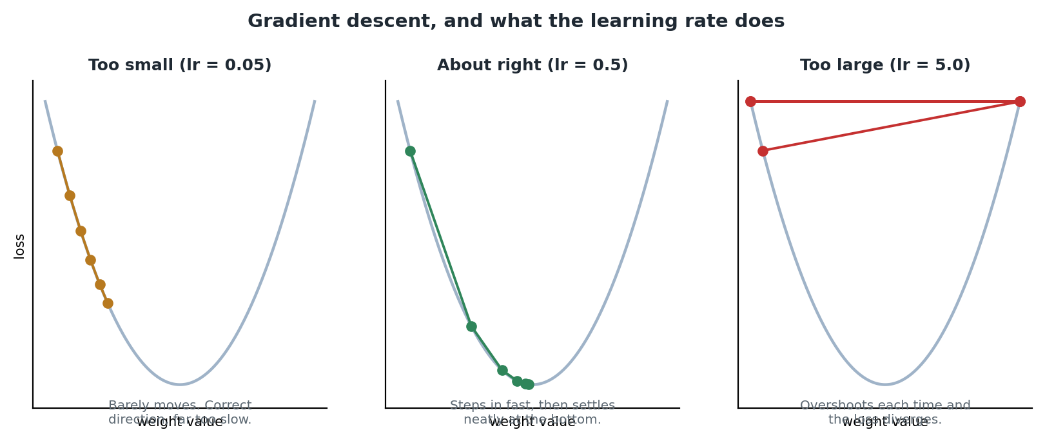
Diagram 7. The same descent with three different step sizes.
The README suggests trying 0.05 and 5.0 to see both failure modes. It is a five-second experiment and it teaches more than reading about it, because you see the loss curve change shape rather than just the final number.

16.4 The chain rule, and why this network avoids it
Working out the gradient for a deep network normally requires the chain rule. The notebook states it plainly: if changing A affects B, and changing B affects C, then the total effect of A on C is found by multiplying the two local sensitivities together.
That is the whole idea. Backpropagation in a real neural network is the chain rule applied repeatedly, one layer at a time, and it is exactly what TensorFlow and PyTorch do automatically for every layer.
This network is simple enough to avoid it. With one layer, softmax combined with cross-entropy has a famously clean gradient:
gradient of loss with respect to the raw scores = predicted probabilities - actual labels
In plain English: for each class, the gradient is simply how far off the predicted probability was from what it should have been, which is 1 for the correct class and 0 for every other.
- If the model was overconfident in a wrong class, the gradient is positive: push that score down.
- If it was underconfident in the correct class, the gradient is negative: push that score up.
- If it was exactly right, the gradient is zero and nothing moves.
The notebook is careful to say it is trusting a well-known result rather than deriving it, and that Step 12 will check it numerically. That is intellectually honest, and it is also the right pedagogic order: use the result, then verify it, rather than demanding a derivation nobody can follow yet.

16.5 The implementation
def compute_gradients(X, probs, y_onehot):
n_samples = X.shape[0]

error = probs - y_onehot # (n, 10)

grad_W = X.T @ error / n_samples # (64, n) @ (n, 10) -> (64, 10)
grad_b = np.mean(error, axis=0) # (10,)

return grad_W, grad_b
Three lines of real work, and each is worth reading carefully.

error
Straight from the formula above. One number per class per sample, saying how far off that class's probability was. Shape (1400, 10).

grad_W
X.T is the transpose of X: its rows and columns swapped, so (1400, 64) becomes (64, 1400). Then (64, 1400) @ (1400, 10) gives (64, 10), which is exactly the shape of W.
Read what that multiplication is doing. Each element of the result is a dot product between one pixel's column of values across all 1,400 images, and one class's column of errors across the same images. In other words: how much did this pixel contribute to this class's error, summed over the whole batch. Dividing by n_samples turns the sum into an average.
One matrix multiplication computes all 640 weight gradients at once. This is the same shape rule from section 12 doing serious work, and it is a good moment to appreciate that matrix multiplication is not just for forward passes.

grad_b
Simply the average error per class across the batch, using axis=0 to collapse the samples. Every sample shares the same bias, so the bias gradient is the average of the errors it contributed to.
In short
A derivative measures sensitivity: nudge this, how much does the output move?
A gradient is one derivative per weight. Gradient descent nudges each weight against its gradient.
For softmax with cross-entropy the gradient is simply predicted minus actual.
X.T @ error computes all 640 weight gradients in one matrix multiplication.
Check you understood
1. In plain English, what does a gradient tell you about one weight?
2. Why is there a minus sign in W -= learning_rate * grad_W?
3. Why is X transposed before the matrix multiplication in grad_W?

17. The training loop and evaluation
Key words in this section
Training step: one pass of forward, loss, gradients, update.
Loss curve: a plot of the loss over the training steps.
Test accuracy: the proportion correct on data held back from training.

17.1 The loop
learning_rate = 0.5
n_steps = 300
loss_history = []

for step in range(n_steps):
probs = forward_pass(x_train, W, b) # 1
loss = cross_entropy_loss(probs, y_train_onehot) # 2
grad_W, grad_b = compute_gradients(x_train, probs, y_train_onehot) # 3

W -= learning_rate * grad_W # 4
b -= learning_rate * grad_b

loss_history.append(loss)
That is the whole of training. Four operations, repeated 300 times.
The notebook draws attention to something easy to miss: every step processes the entire batch of 1,400 images at once, as vectorised array maths. There is no per-image Python loop anywhere in this training loop. The only loop is over training steps.
That is why it finishes in a fraction of a second per step instead of the minutes a naive loop-based version would take. Recall the benchmark in section 12.4: one layer, one small batch, and the loop version was already dramatically slower. Now imagine that repeated 300 times.
The cell resets W and b to fresh random values at the top, so it can be re-run from a clean start. Without that, running the cell twice would continue training an already-trained model, which quietly makes any comparison meaningless. This is a small piece of careful notebook design worth copying.

17.2 What the four lines correspond to
If you have read the TensorFlow or PyTorch guides, this table is the payoff. The same four operations appear in all three projects.
This notebook | PyTorch | Keras
probs = forward_pass(...) | outputs = model(images) | Inside model.fit()
loss = cross_entropy_loss(...) | loss = criterion(outputs, labels) | Inside model.fit()
grad_W, grad_b = compute_gradients(...) | loss.backward() | Inside model.fit()
W -= learning_rate * grad_W | optimizer.step() | Inside model.fit()
Written by you | Written by you | Written by the framework
The frameworks add real value: automatic gradients for architectures where the formula is not clean, GPU support, optimisers cleverer than plain gradient descent, and a great deal of tested infrastructure. But the core is what you see in the left column. Having written it once, you know what the others are doing.

17.3 The loss curve
plt.plot(loss_history)
plt.xlabel("Training step")
plt.ylabel("Cross-entropy loss")
Plotting the loss is the single most useful diagnostic in machine learning, and it costs three lines. Learn to read the shape.
Shape | What it means | What to do
Falls steeply, then flattens | Healthy. The usual shape, and what you should see here. | Nothing.
Falls very slowly and is still falling at the end | Learning rate too small, or too few steps. | Increase either.
Jumps around, or rises | Learning rate too large. The steps are overshooting. | Reduce it, perhaps by a factor of ten.
Flat from the start | Nothing is learning. Often a bug rather than a tuning problem. | Check the gradients are non-zero and that W is actually being updated.
Falls to near zero | On this dataset, possibly memorising rather than learning. | Check the test accuracy, not just the loss.

17.4 Evaluation
test_probs = forward_pass(x_test, W, b)
test_predictions = np.argmax(test_probs, axis=1)
accuracy = np.mean(test_predictions == y_test)
Three lines, and the last one is a small lesson in itself. test_predictions == y_test is an element-wise comparison producing an array of True and False, one per test image. Taking the mean of booleans treats True as 1 and False as 0, so the mean is exactly the proportion correct.
No loop, no counter, no if statement. Comparison and mean. This is the array-thinking habit again, and once you notice it you will start writing this way by reflex.
The evaluation uses x_test, which the model has never seen. Section 13.3 explained why: scoring on data the model learned from tells you how well it memorised, not how well it will handle anything new.

17.5 What the notebook says about the result
The notebook prints a note alongside the accuracy that is worth quoting in spirit: reaching this from nothing but arrays, dot products and a loop of vector subtractions is exactly what every deep learning framework is doing underneath, at much bigger scale. More layers, more data, and GPU acceleration, but the same core maths.
That is the claim the entire notebook has been building towards, and by this point you have the evidence for it yourself rather than being asked to believe it.
In short
Training is four operations repeated 300 times: forward, loss, gradients, update.
Every step handles all 1,400 images at once. The only Python loop is over steps.
Plot the loss curve. Its shape tells you more than its final value.
np.mean(predictions == labels) computes accuracy with no loop and no counter.

18. Checking the maths: gradient checking
Key words in this section
Analytic gradient: the one computed by a formula.
Numerical gradient: the one estimated by actually nudging a weight.
Epsilon: the size of that nudge.
Section 16.4 used a known formula without deriving it. The notebook is not content to leave it there, and Step 12 verifies it numerically using nothing more advanced than the definition of a derivative.
This step is optional in the sense that the model already works without it. It is also the most professionally valuable thing in the notebook, because verifying your own maths is a habit that separates code that happens to run from code you can trust.

18.1 The idea
A derivative measures what happens to the output when you nudge the input a tiny bit. So you can approximate one directly, with no calculus at all, by actually nudging it and measuring the difference.
approximate gradient ~ (loss with weight nudged UP - loss with weight nudged DOWN)
--------------------------------------------------------
2 x nudge size
Nudge one weight up by a tiny amount, measure the loss. Nudge it down by the same amount, measure again. The difference divided by the total distance moved is the slope.
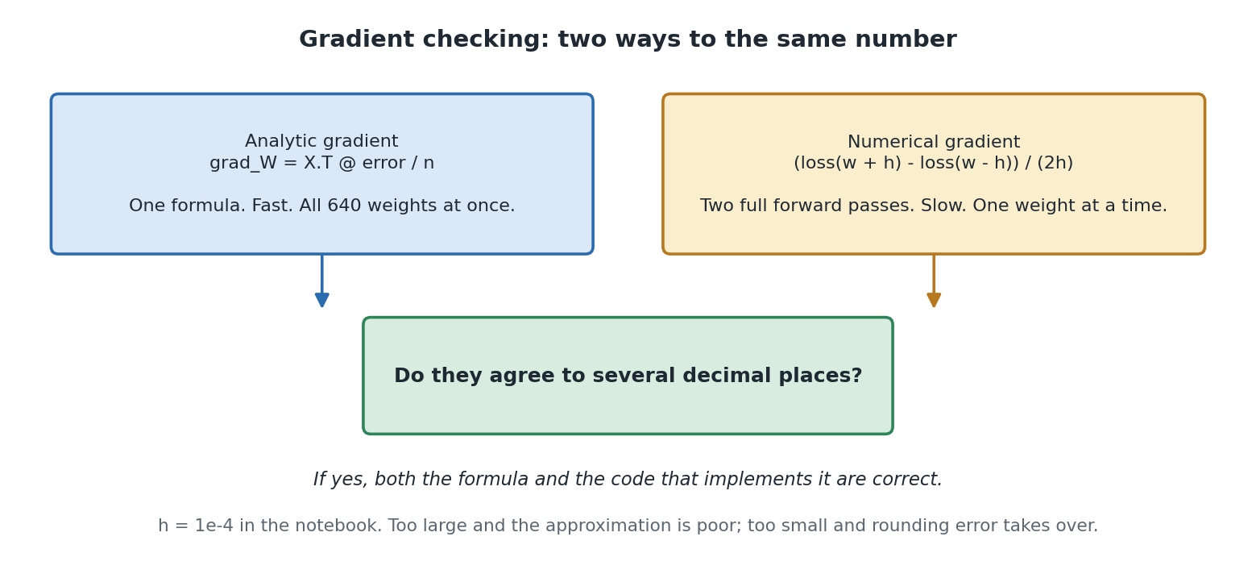
Diagram 8. Two routes to the same number. If they agree, both the formula and the code are right.

18.2 The implementation
def numerical_gradient_check(X, y_onehot, W, b, row, col, epsilon=1e-4):
original_value = W[row, col]

W[row, col] = original_value + epsilon
loss_up = cross_entropy_loss(forward_pass(X, W, b), y_onehot)

W[row, col] = original_value - epsilon
loss_down = cross_entropy_loss(forward_pass(X, W, b), y_onehot)

W[row, col] = original_value # restore it exactly as we found it
return (loss_up - loss_down) / (2 * epsilon)
Read what it costs. Two complete forward passes over the data, for one single weight. The analytic version computed all 640 gradients in one matrix multiplication.
That is why real training never uses the numerical method: it is thousands of times slower. It is an excellent check and a useless training algorithm, and knowing the difference is part of the lesson.
Note the restore line. The function puts the weight back exactly as it found it, so checking a gradient does not quietly alter the model. Any function that temporarily modifies shared state and does not restore it is a bug waiting to appear somewhere else entirely.

18.3 Why epsilon is 1e-4
This is not in the notebook and it is worth knowing, because the choice is a genuine trade-off between two opposite errors.
- Too large, say 0.1, and you are measuring the slope across a wide gap rather than at a point. The approximation is poor because the curve bends over that distance.
- Too small, say 1e-12, and the two losses are almost identical. Subtracting two nearly equal floating point numbers destroys precision, and the result is dominated by rounding error rather than by the real difference.
1e-4 sits comfortably between the two. This kind of trade-off, where both extremes fail for opposite reasons, is common in numerical computing and worth recognising as a pattern.

18.4 What the check proves
The notebook checks four specific weights and compares the two methods side by side. They should match to several decimal places.
When they do, two things have been confirmed at once, and the notebook names both:
1. The well-known softmax and cross-entropy gradient formula really is correct.
2. The NumPy implementation of it in compute_gradients is bug-free.
That second one is the practical value. A correct formula implemented wrongly gives a model that trains badly for reasons you will struggle to find, because nothing errors and the loss does fall, just not as it should. Gradient checking catches exactly that failure, and it is standard practice when implementing gradients by hand.
In short
You can estimate any gradient by nudging the weight up and down and measuring the loss change.
It is far too slow for training and ideal as a check.
Agreement between the analytic and numerical gradients confirms both the maths and the code.
Epsilon of 1e-4 balances approximation error against floating point rounding error.
Check you understood
1. Why is the numerical gradient never used for actual training?
2. What two things does a successful gradient check confirm?
3. Why would an epsilon of 1e-12 give a worse answer than 1e-4?

19. How this connects to real frameworks
The notebook's summary makes the connection explicitly, and it is worth expanding because it is the reason the whole lesson is structured as it is.
Everything a library like TensorFlow or PyTorch does is this notebook's ideas, automated and scaled up.
In this notebook | In a real framework
x_train / 16.0, dividing pixels by their maximum | The same normalisation, sometimes automatic as in torchvision's ToTensor
X @ W + b in forward_pass | A Dense layer in Keras, or nn.Linear in PyTorch
Your softmax function | activation="softmax", or applied inside the loss function
cross_entropy_loss | sparse_categorical_crossentropy in Keras, nn.CrossEntropyLoss in PyTorch
compute_gradients, a formula you wrote | loss.backward(), computed automatically by autograd for any architecture
W -= learning_rate * grad_W | optimizer.step(), usually with a cleverer algorithm than plain gradient descent
The 300-step for loop | model.fit(...) in Keras, or a loop you write in PyTorch
NumPy arrays on the CPU | Tensors, which can live on a GPU

19.1 What the frameworks add
It would be a mistake to conclude the frameworks are unnecessary. What they add is substantial.
- Automatic differentiation. This notebook could use a one-line gradient formula because the architecture is simple. Add a hidden layer and you must derive the gradient yourself using the chain rule. A framework computes it for any architecture you can write.
- GPU acceleration. The same matrix multiplications, running on hardware built for them, often a hundred times faster again.
- Better optimisers. Adam and its relatives adapt the step size per weight, rather than using one fixed learning rate for everything.
- Layer libraries, data loading, saving and loading, and a great deal of tested infrastructure you would otherwise write yourself.

19.2 What you gain from having done it by hand
- The frameworks stop being magic. model.fit is a loop doing four things, and you have written all four.
- Shape errors become readable rather than frightening, because you know what shape each thing should be and why.
- You can debug at a level most people cannot. When a framework misbehaves, knowing what it is trying to do underneath is what lets you work out why.
- You can implement something the framework does not offer, because you know what the pieces are.
The README's final extension suggestion is to rebuild this same model in TensorFlow or PyTorch and compare. That is an excellent exercise, and doing it in this order, by hand first, is much more instructive than the reverse.

20. Errors you will actually meet
This section is not in the notebook. It is here because a lesson on a library is only half learned until you can read its error messages, and NumPy's are better than most once you know how to read them.

20.1 Shape errors
Message | What it means | How to fix it
operands could not be broadcast together with shapes (3,4) (3,) | Broadcasting failed. Lined up from the right, 4 against 3 is neither equal nor 1. | Print both shapes. Either reshape one, or realise you meant a different operation.
matmul: Input operand 1 has a mismatch in its core dimension | The inner dimensions of a @ do not match. | Apply the rule from section 12.2. You may need a transpose, as grad_W does.
cannot reshape array of size 1400 into shape (64,10) | The total number of elements does not match. | Multiply out the target shape and compare with .size.
setting an array element with a sequence | You tried to put an array where a single number was expected. | Usually an indexing mistake. Check whether you meant a[i] or a[i, j].
too many indices for array | You indexed more dimensions than the array has. | Check .ndim. A common cause is indexing a 1-D array as if it were 2-D.
Every one of these is diagnosed the same way: print the shapes of everything involved, immediately before the failing line. It sounds too simple to be a technique and it resolves the large majority of NumPy errors.

20.2 Errors that do not error
More dangerous are the ones that run happily and give you a wrong answer. These are the ones worth learning to anticipate.
The mistake | What happens | How to catch it
Using * where you meant @ | Element-wise multiplication instead of matrix multiplication. If shapes happen to be compatible, it runs. | Check the result's shape against what you expected.
Wrong axis in an aggregation | Collapsing the wrong dimension. Perfectly valid, entirely wrong. | The disappearing-dimension rule from section 11.1. Check the output shape.
Forgetting keepdims | The result no longer broadcasts as intended, and may broadcast in some other way instead. | Check the shape after every aggregation you intend to broadcast.
Modifying a slice | Basic slices are views, not copies, so changing the slice changes the original. | Use .copy() if you want an independent array.
Integer division of an integer array | Dividing an int array can surprise you with dtype changes. | Divide by a float, as the notebook does with 16.0 rather than 16.
Forgetting to shuffle before splitting | Your test set may contain entirely different classes from your training set. | Check the class distribution of both splits.
That third-from-last row is worth extra attention. A basic slice returns a view onto the same memory, so modifying it modifies the original. Fancy indexing and boolean masking, by contrast, return copies. The inconsistency is a genuine wart in NumPy and a common source of confusing bugs.

20.3 A debugging checklist
1. Print the shape of every array involved, immediately before the failing line.
2. Check dtypes if the numbers look wrong rather than the shapes. Integer arrays behave differently from float ones.
3. Test on a tiny array you can verify by hand. Three rows, four columns, and check the answer yourself.
4. Check the result's shape against what you expected, not just that it ran.
5. If a value is nan, look for a division by zero or a log of zero. Trace back to the first place it appears.
6. Restart the kernel and run from the top. Notebook state is a common cause of impossible-looking behaviour.

21. Practice exercises
Work these out before reading the answers. The first group needs only Steps 1 to 10; the second group draws on the capstone. Several are taken from the README's own extension suggestions.

21.1 Core NumPy
E1. Create an array of the ten even numbers from 0 to 18, then reshape it into a 2 by 5 grid.
np.arange(0, 20, 2).reshape(2, 5). Note arange excludes its stop value, so 20 gives you up to 18. Reshape works because 2 times 5 is 10.
E2. Given a (5, 3) array, get the second column as a 1-D array, then as a (5, 1) column.
a[:, 1] gives shape (5,). For (5, 1) use a[:, 1:2], or a[:, 1].reshape(-1, 1), or a[:, [1]]. The difference matters when you want to broadcast the result back against the original.
E3. Set every value in an array that is below 5 to zero, without a loop.
a[a < 5] = 0. A boolean mask used on the left of an assignment. Alternatively np.where(a < 5, 0, a), which returns a new array instead of modifying in place.
E4. Will shapes (4, 1) and (3,) broadcast? What shape results?
Yes. From the right: 1 against 3 is compatible because one of them is 1, then 4 against nothing is fine. The result is (4, 3). This one surprises people because neither input has that shape.
E5. An array has shape (100, 10). Which axis gives you the mean of each row, and what shape results?
axis=1, giving shape (100,). Remember the axis you pass is the one that disappears. With keepdims=True you would get (100, 1) instead.
E6. Compute the dot product of [2, 0, 1] and [3, 4, 5] by hand, then check with NumPy.
(2 x 3) + (0 x 4) + (1 x 5) = 6 + 0 + 5 = 11. Check with np.array([2,0,1]) @ np.array([3,4,5]).
E7. A (32, 784) batch goes into a layer with 256 neurons. What shape must the weight matrix be, and what comes out?
The weights must be (784, 256), because the inner dimensions must match. The output is (32, 256). The bias would be shape (256,), broadcast across all 32 rows.
E8. Count how many elements of an array are greater than 10, without a loop.
np.sum(a > 10). The comparison gives booleans, and summing booleans counts the Trues. The same trick as the accuracy calculation in section 17.4.

21.2 The capstone
E9. Change the learning rate in Step 11e to 0.05, then to 5.0. Predict what the loss curve will look like before running each.
At 0.05 the loss falls much more slowly and is probably still falling at step 300: correct direction, too slow. At 5.0 it may oscillate, spike, or fail to settle, because each step overshoots. Compare against Diagram 7.
E10. Why does the Step 11e cell reset W and b at the top?
So it can be re-run from a clean start. Without the reset, running it twice would continue training an already-trained model, so you would be comparing 600 steps against 300 without realising it.
E11. Remove the row-maximum subtraction from softmax and feed it large scores, say 1000.
np.exp(1000) overflows to inf, then inf divided by inf gives nan, and every downstream number becomes nan. The subtraction changes nothing mathematically and prevents this entirely. Section 14.4.
E12. Predict the untrained loss before running Step 11c, and explain your reasoning.
About 2.303. With ten classes and small random weights every probability is close to 0.1, and the loss is -log(0.1) = 2.303. If you get something far from this, check the labels and the one-hot encoding before doing anything else.
E13. Split the training into mini-batches of 100 rather than using all 1,400 each step.
Loop over slices of x_train, computing gradients and updating on each slice. You get 14 updates per pass instead of 1, so it usually converges in fewer passes. The gradients are noisier because each is based on less data, and that noise is not purely a cost: it can help avoid settling in a poor spot.
E14. In the gradient check, try epsilon of 1e-1 and then 1e-12. Explain both results.
At 1e-1 the nudge is too wide, so you measure an average slope across a curve rather than the slope at a point, and agreement worsens. At 1e-12 the two losses are almost identical, and subtracting nearly equal floats destroys precision, so rounding error dominates. Section 18.3.
E15. The README suggests adding a hidden layer with ReLU. What would that break?
The clean gradient formula. probs - y_onehot gives the gradient at the output layer only. To reach the hidden layer's weights you need the chain rule, multiplying sensitivities back through the ReLU and the second weight matrix. That is backpropagation, and it is exactly what a framework would do for you.
E16. Rebuild this model in Keras or PyTorch and compare it against the NumPy version.
A Dense(10, softmax) or Linear(64, 10) layer, a categorical crossentropy loss, and an optimizer. You should get comparable accuracy. The instructive part is the mapping: every line of the framework version corresponds to something you wrote by hand here. Section 19.

22. Test yourself
Answer each before reading the answer underneath.
Q1. Why can't you subtract one Python list from another?
Python has no definition for what subtracting two lists should mean, so it raises a TypeError rather than guessing. Multiplication is arguably worse: it repeats the list instead of scaling it, which succeeds and gives you the wrong kind of answer.
Q2. Give the two separate reasons a NumPy array is faster than a list.
First, storage: values sit contiguously in one block with one shared dtype, rather than as pointers to scattered objects each carrying type information. Second, vectorisation: whole-array operations run as compiled C, avoiding Python interpreter overhead on every element.
Q3. Does vectorised code avoid looping?
No. The loop still happens, but inside compiled code rather than in the Python interpreter. What is avoided is the per-iteration overhead, not the iteration.
Q4. State the broadcasting rule.
Compare shapes dimension by dimension from the right. Two dimensions are compatible if they are equal, or if one of them is 1, in which case the size-1 dimension is stretched. Otherwise NumPy raises an error.
Q5. Which dimension does axis=1 collapse, and what is the memory trick?
It collapses the columns, giving one result per row. The trick: the axis number you pass is the dimension that disappears from the result.
Q6. State the matrix multiplication shape rule.
(m x n) @ (n x p) -> (m x p). The inner dimensions must match, and that shared number is what each dot product sums away.
Q7. What is the difference between a * b and a @ b?
a * b multiplies matching elements, giving an array of the same shape. a @ b is matrix multiplication: dot products of rows against columns, following the shape rule. They are different operations and confusing them is a common source of wrong answers that do not error.
Q8. What does a dense or linear layer compute?
output = inputs @ weights + bias, followed by an activation function. Every neuron is one column of the weight matrix, dot-producted against the inputs.
Q9. Why does softmax subtract the row maximum before exponentiating?
Purely for numerical stability. It cancels out in the division so the result is unchanged, but it guarantees the largest value passed to exp is 0, preventing overflow to infinity.
Q10. In plain English, what is a gradient?
One derivative per weight. Each one says: if I nudge this weight up slightly, does the loss go up or down, and roughly by how much? It is a measure of sensitivity.
Q11. Why is there a minus in W -= learning_rate * grad_W?
The gradient points uphill, in the direction that increases the loss. You want to reduce the loss, so you move against it.
Q12. What is the gradient of softmax with cross-entropy, and why is it convenient?
predicted probabilities minus actual one-hot labels. It is convenient because it needs no chain rule, which is what makes this one-layer capstone tractable without calculus.
Q13. Why does the notebook use np.allclose rather than == when comparing results?
Floating point arithmetic performed in a different order gives answers that differ in the last few decimal places. Exact equality would fail even though both answers are correct, so allclose asks whether they agree within a tolerance.
Q14. Explain np.mean(predictions == labels).
The comparison gives an array of True and False, one per sample. Taking the mean treats True as 1 and False as 0, so the result is the proportion correct. Accuracy with no loop, no counter and no conditional.
Q15. What two things does a successful gradient check confirm?
That the gradient formula itself is correct, and that the code implementing it has no bugs. The second is the practical value: a correct formula implemented wrongly still trains, just badly, and for reasons that are very hard to find.
Q16. Why does the capstone shuffle before splitting into train and test?
The dataset is stored in repeating blocks of digits 0 to 9. Splitting without shuffling could leave entire digits absent from one set, which would be catastrophic and not obviously so from the accuracy figure alone.

23. Glossary
Word | What it means here
Aggregation | Collapsing many numbers into fewer, such as sum, mean, max or argmax.
argmax | The position of the largest value, rather than the value itself. With axis=1, the winning class per row.
Array (ndarray) | NumPy's core type: a grid of numbers, all the same type, stored in one contiguous block.
axis | Which dimension an aggregation collapses. The axis you name is the one that disappears.
Bias | A learned number added after the weighted sum. In the capstone, a vector of 10, one per class.
Boolean mask | An array of True and False, used to select elements by condition.
Broadcasting | NumPy's rule for combining arrays of different but compatible shapes, without copying data.
Chain rule | Multiplying local sensitivities along a chain of dependent calculations. The basis of backpropagation.
Contiguous memory | Values stored next to each other in one block, which hardware can read quickly.
Cross-entropy loss | The negative log of the probability given to the correct class. Punishes confident wrong answers heavily.
Derivative | How much an output changes when you nudge an input slightly. A measure of sensitivity.
Dot product | Multiply matching elements of two vectors, then add the results. A weighted sum.
dtype | The single data type shared by every element of an array.
Element-wise | An operation applied to matching pairs of elements, such as a + b or a * b.
Epsilon | The size of the nudge in a numerical gradient check. 1e-4 in the notebook.
Fancy indexing | Selecting elements using a list of positions. Can reorder and repeat. Returns a copy.
Flatten | Collapsing an array into one dimension, as reshape(-1) does.
Forward pass | Running data through the model to produce a prediction.
Gradient | One derivative per weight, collected together. One sensitivity score per weight.
Gradient checking | Verifying a gradient formula by estimating it numerically and comparing.
Gradient descent | Repeatedly nudging every weight a small step against its gradient, to reduce the loss.
Identity matrix | A square array with 1s on the diagonal and 0s elsewhere. np.eye. Used here for one-hot encoding.
keepdims | An aggregation option that keeps the collapsed dimension at size 1, so the result still broadcasts.
Learning rate | How big a step gradient descent takes on each update. 0.5 in the capstone.
Logits or scores | The raw, unbounded numbers before softmax turns them into probabilities.
Loss | A single number measuring how wrong a prediction was. Training tries to reduce it.
Matrix | A 2-D array. One 8 by 8 image, or the (64, 10) weight matrix.
Matrix multiplication | Many dot products at once: every row of one matrix against every column of another. The @ operator.
ndim | How many dimensions an array has.
Normalisation | Scaling values into a small consistent range. Here, dividing pixels by 16.0.
One-hot encoding | Representing a label as a row of zeros with a single 1 at the label's position.
reshape | Rearranging the same numbers into a different shape. -1 means work this dimension out for me.
Scalar | A single number. A 0-D array, shape ().
Seed | A fixed starting point that makes random numbers reproducible between runs.
shape | A tuple giving the size along each dimension. The property you will print most often.
size | The total number of elements in an array.
Slice | Selecting a range with a colon. Basic slices are views onto the original, not copies.
Softmax | Converts a row of raw scores into positive probabilities that sum to 1.
Softmax regression | A classifier with no hidden layers, going straight from inputs to class scores. What the capstone builds.
Tensor | An array with three or more dimensions. All 1,797 images stacked is a tensor of shape (1797, 8, 8).
Transpose | Swapping an array's rows and columns. a.T. Used in the weight gradient calculation.
Vector | A 1-D array. One row of pixels, or the bias.
Vectorisation | Expressing an operation on a whole array at once, so the looping happens in compiled code.
View | An array sharing memory with another. Modifying a view modifies the original.
Weight | A learned number saying how much one input contributes to one output.

24. NumPy quick reference
Everything the notebook uses, grouped by job.

24.1 Creating arrays
Call | Result
np.array([1, 2, 3]) | An array from a list
np.zeros(5) / np.zeros((2, 3)) | Filled with 0.0
np.ones((2, 3)) | Filled with 1.0
np.full(4, 7) | Filled with a value you choose
np.arange(0, 10, 2) | Like range, as an array. Stop excluded.
np.linspace(0, 1, 5) | n evenly spaced values. Stop included.
np.eye(3) | Identity matrix
np.random.default_rng(seed=42) | A seeded random generator
rng.random(4) / rng.integers(0, 10, size=5) | Random floats / whole numbers
rng.normal(loc=0.0, scale=0.01, size=(64, 10)) | From a normal distribution. Used to initialise W.
rng.permutation(n) | A shuffled arrangement of 0 to n-1. Used to shuffle the dataset.

24.2 Describing and reshaping
Call | Result
a.shape / a.size / a.ndim / a.dtype | Dimensions, element count, number of dimensions, element type
a.reshape(8, 8) | Same numbers, new shape. Total size must match.
a.reshape(-1, 64) | 64 columns, rows worked out automatically
a.reshape(-1) | Flatten to 1-D
a.T | Transpose: rows and columns swapped

24.3 Selecting
Call | Result
a[1, 2] | One element: row 1, column 2
a[0, :] / a[:, 1] | A whole row / a whole column
a[0:2, 0:2] | A rectangular sub-region. Stop excluded.
a[-1, :] | The last row
a[a > 20] | Boolean mask: only where the condition holds. Returns a flat copy.
a[[0, 2]] | Fancy indexing: those rows, in that order
identity[labels] | Fancy indexing with a whole array. The one-hot trick.

24.4 Maths
Call | Result
a + b / a - b / a * b / a / b | Element-wise arithmetic, with broadcasting
a ** 2 | Every element squared
a @ b or np.dot(a, b) | Dot product or matrix multiplication
np.exp(a) / np.log(a) | Element-wise exponential and natural log
np.allclose(a, b) | Do these agree within floating point tolerance?

24.5 Aggregating
Call | Result
a.sum() / a.mean() / a.max() | Collapse the whole array to one number
a.sum(axis=0) | One result per column. Shape (m, n) becomes (n,).
a.sum(axis=1) | One result per row. Shape (m, n) becomes (m,).
a.max(axis=1, keepdims=True) | Same, but the collapsed dimension is kept at size 1, so it still broadcasts
np.argmax(a, axis=1) | The position of the largest value in each row: the predicted class
np.mean(a == b) | Proportion of matching elements: accuracy

24.6 The capstone in twelve lines
Everything the notebook builds, condensed. If you can read this and know what each line does, you have understood the lesson.
x_train = x_train_raw.reshape(-1, 64) / 16.0 # flatten and normalise
y_onehot = np.eye(10)[y_train] # one-hot the labels

W = rng.normal(0.0, 0.01, size=(64, 10)) # small random weights
b = np.zeros(10) # zero bias

for step in range(300):
scores = x_train @ W + b # matmul + broadcast
shifted = scores - scores.max(axis=1, keepdims=True)
probs = np.exp(shifted) / np.exp(shifted).sum(axis=1, keepdims=True)

error = probs - y_onehot # the gradient, directly
W -= 0.5 * (x_train.T @ error / len(x_train)) # gradient descent
b -= 0.5 * error.mean(axis=0)

25. Where this information came from
Source | Used for
numpy_fundamentals.ipynb | All the code, the step structure, the explanations of vectorisation, broadcasting, axis, dot products, softmax, cross-entropy, gradients and gradient checking, and the summary and glossary.
README.md | The package list, setup and running instructions, the note on dataset choice, and the extension exercises used in section 21.
requirements.txt | The five packages in section 3.1.

25.1 What has been added
The following is material added by this guide rather than taken from the notebook, so you know the difference: section 6.4 on when vectorisation does not help, section 9's note on masks returning copies, section 11.4 on keepdims, section 18.3 on the choice of epsilon, section 19.1 on what frameworks add, section 20 in full, and the exercises and questions in sections 21 and 22. The comparison with the TensorFlow and PyTorch projects in sections 12.3, 17.2 and 19 draws on those separate projects rather than on this notebook.
Timings and accuracy figures are not quoted as specific numbers anywhere in this guide, because the notebook's cells were not executed during this analysis and both vary between machines and runs. Where the notebook states an expected range, such as the tens-to-hundredfold speedup in Step 4, that range is reported as the notebook gives it.

